- 3 Runs of k(6,6)
  - True genus of 4
  - Solution Space Genus Distribution: 3 runs of 43276 samples each.
    - 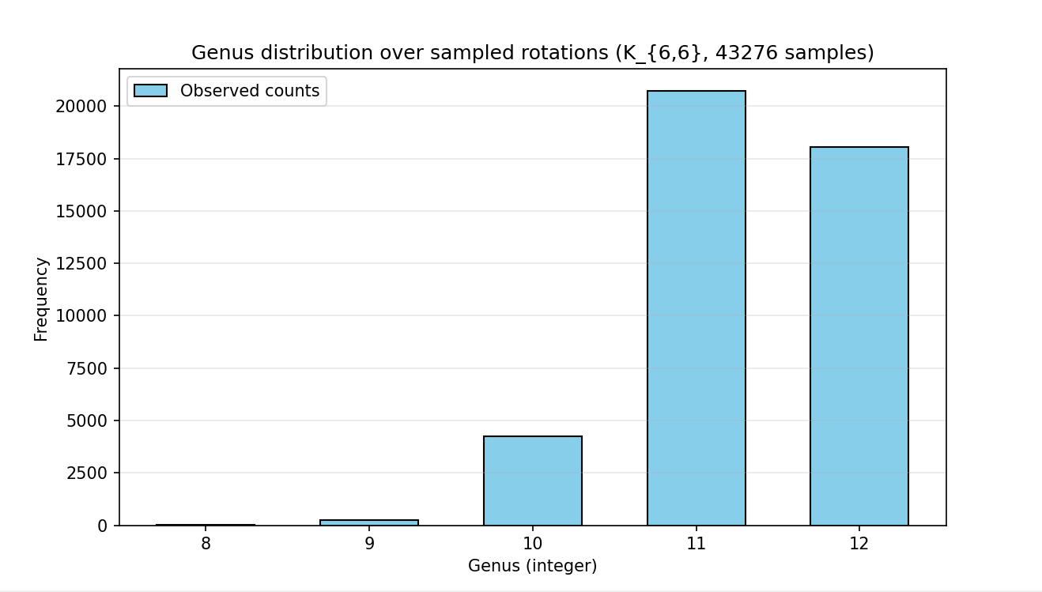
    - 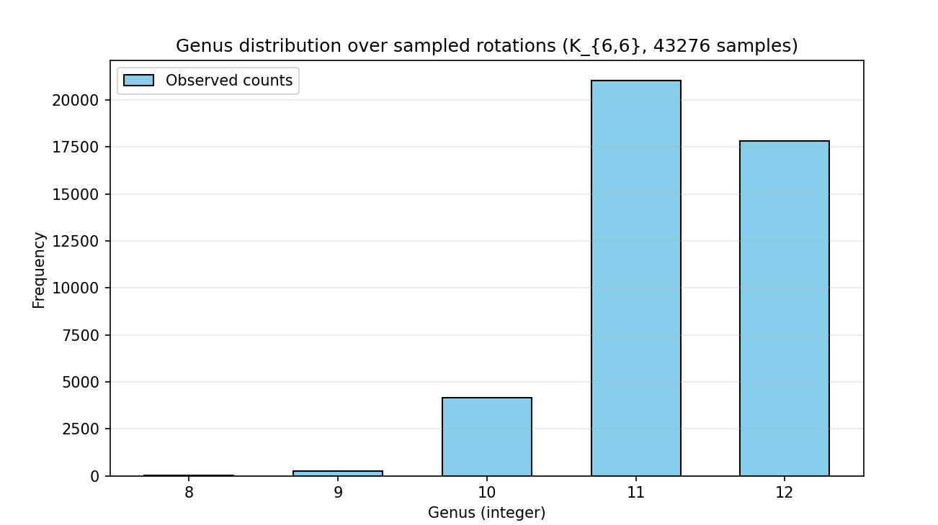
    - 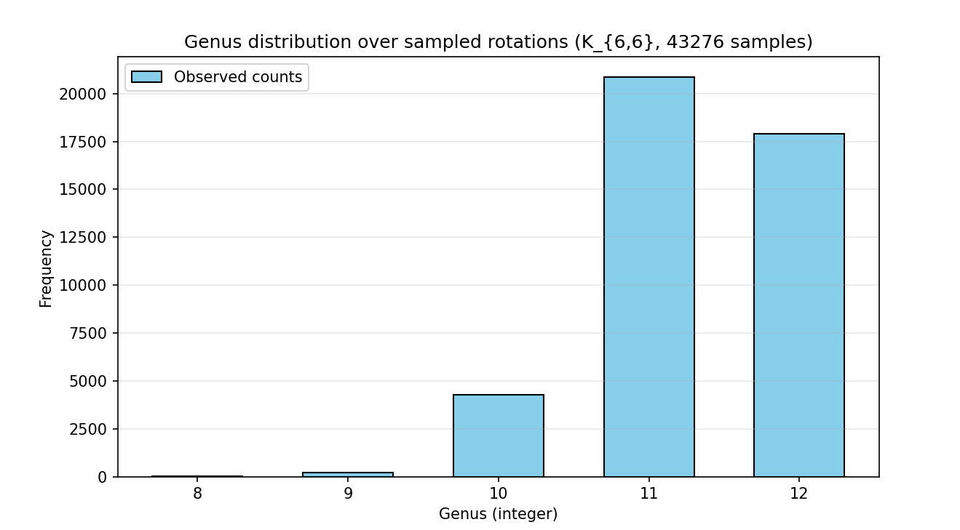

  - Vertex: 2 swap
    - single-vertex 2-swap method failed to find optimal solution (found 5.0, expected 4)
    - single-vertex 2-swap method failed to find optimal solution (found 5.0, expected 4).
    - single-vertex 2-swap method failed to find optimal solution (found 5.0, expected 4).
  - Vertex segment reversal:
    - segment reversal method failed to find optimal solution (found 6.0, expected 4)
    - segment reversal method failed to find optimal solution (found 5.0, expected 4).
    - segment reversal method failed to find optimal solution (found 5.0, expected 4).
  - Edge moving:
    - edge-targeted dart method failed to find optimal solution (found 5.0, expected 4).
    - edge-targeted dart method failed to find optimal solution (found 5.0, expected 4).
    - edge-targeted dart method failed to find optimal solution (found 6.0, expected 4).
  - Full vertex shuffle
    - Found optimal solution (g=4.0)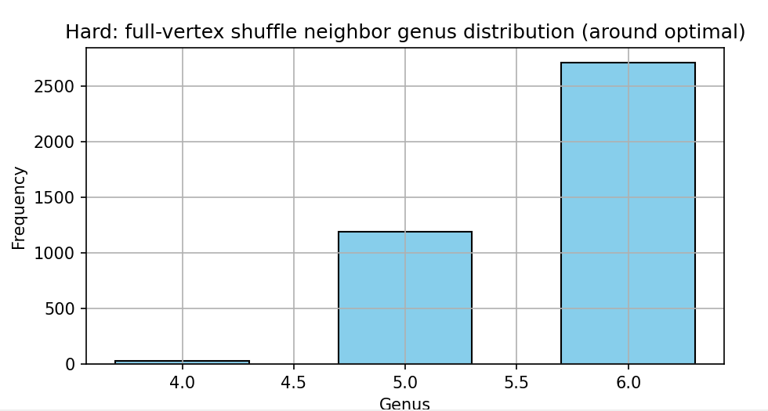
    - full-vertex shuffle method failed to find optimal solution (found 5.0, expected 4).
    - full-vertex shuffle method failed to find optimal solution (found 5.0, expected 4).

  - Multi-Neighborhood (using multiple defs of neighborhood):
    - 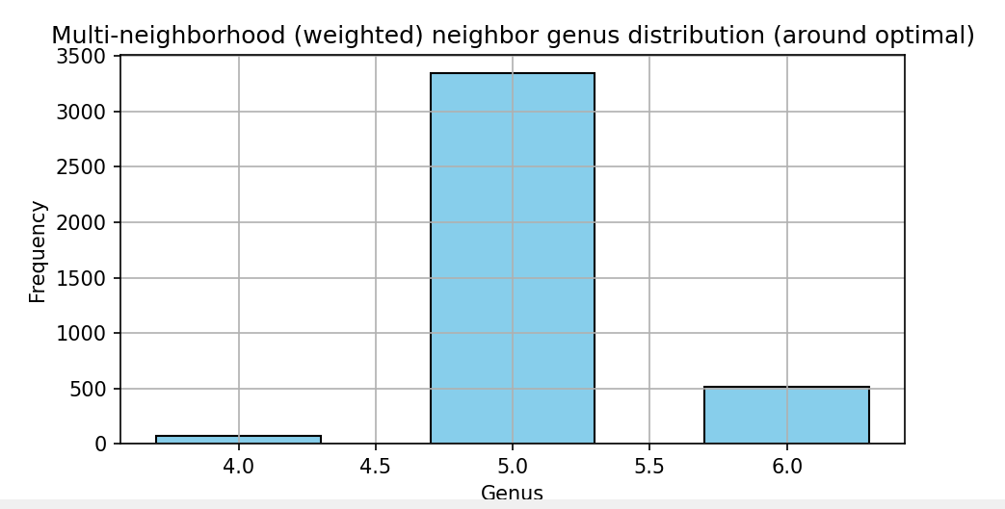
    - 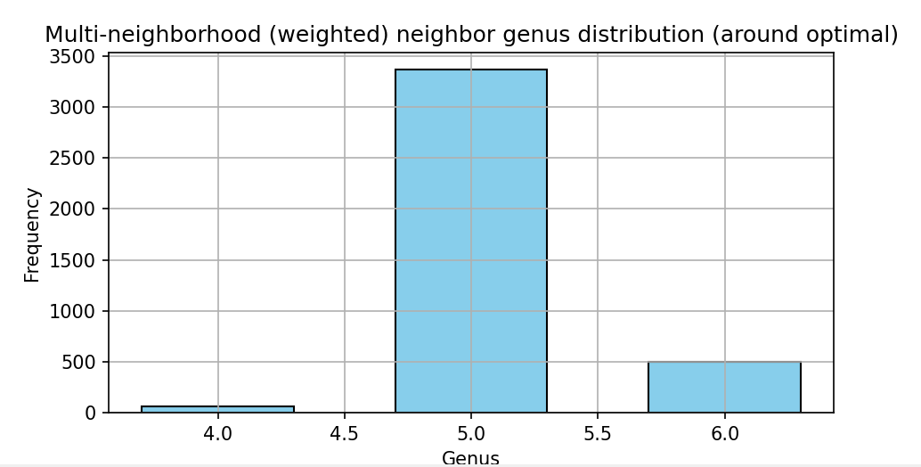
    - 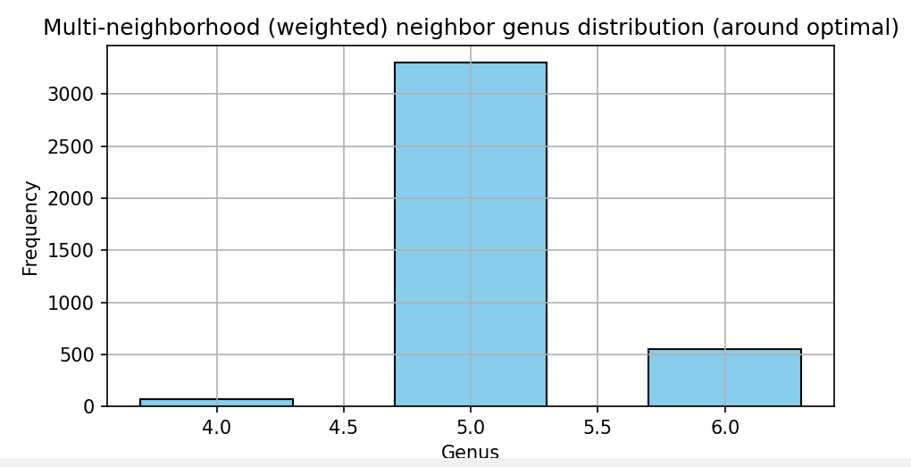

- 3 runs of K(8,8)
  - True Genus of 9
  - Solution space genus distribution
    - 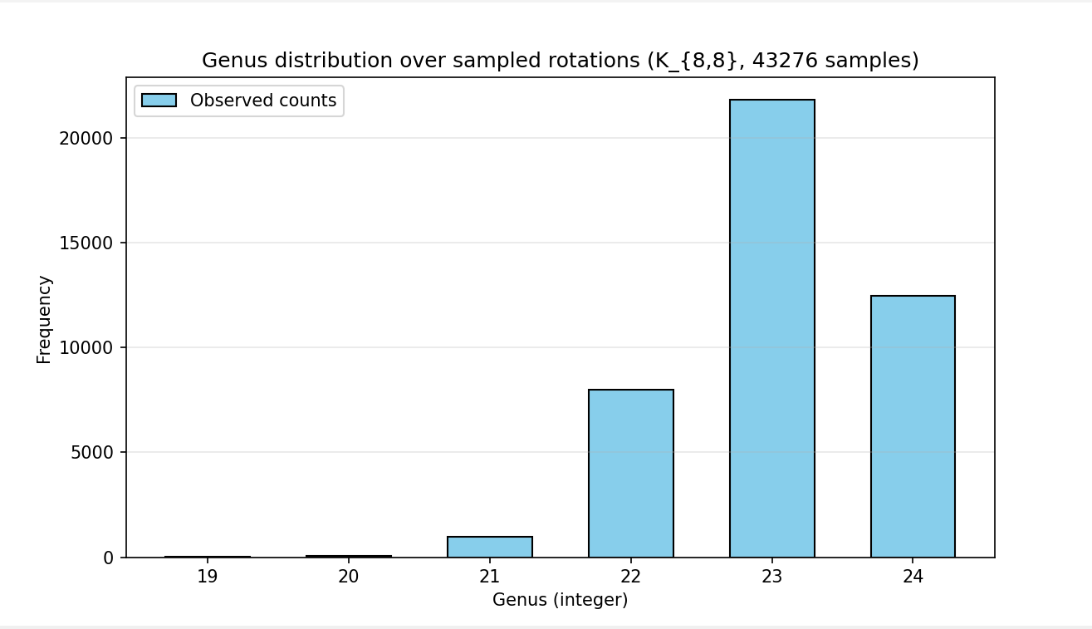
    - 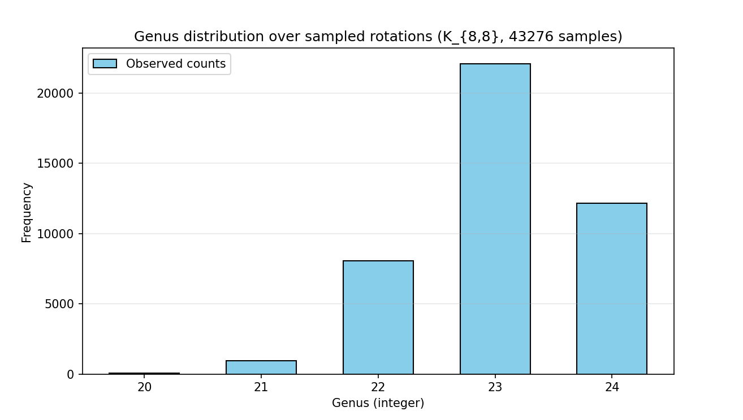
    - 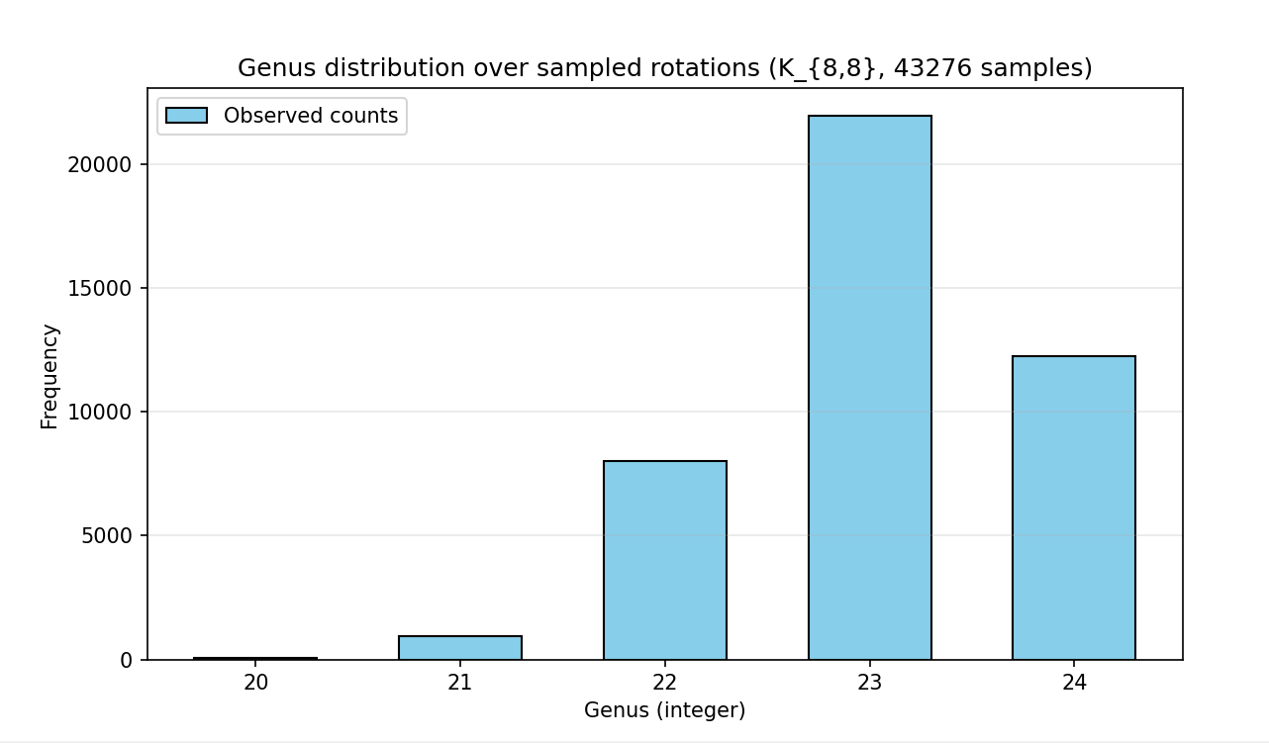

  - Vertex 2 swap
    - single-vertex 2-swap method failed to find optimal solution (found 11.0, expected 9).
    - single-vertex 2-swap method failed to find optimal solution (found 11.0, expected 9).
    - single-vertex 2-swap method failed to find optimal solution (found 10.0, expected 9).
  - Vertex segment reversal
    - segment reversal method failed to find optimal solution (found 12.0, expected 9).
    - segment reversal method failed to find optimal solution (found 11.0, expected 9).
    - segment reversal method failed to find optimal solution (found 11.0, expected 9).
  - Vertex edge moving
    - edge-targeted dart method failed to find optimal solution (found 13.0, expected 9).
    - edge-targeted dart method failed to find optimal solution (found 13.0, expected 9).
    - edge-targeted dart method failed to find optimal solution (found 13.0, expected 9).
  - Vertex full shuffle
    - full-vertex shuffle method failed to find optimal solution (found 11.0, expected 9).
    - full-vertex shuffle method failed to find optimal solution (found 12.0, expected 9).
    - full-vertex shuffle method failed to find optimal solution (found 12.0, expected 9).
  - Multi-neighborhood
    - Multi-neighborhood (weighted) method failed to find optimal solution (found 11.0, expected 9).
    - Multi-neighborhood (weighted) method failed to find optimal solution (found 10.0, expected 9).
    - Multi-neighborhood (weighted) method failed to find optimal solution (found 10.0, expected 9).

- 3 runs of K(9,9)
  - True Genus of 13
  - Solution space genus distribution
    - 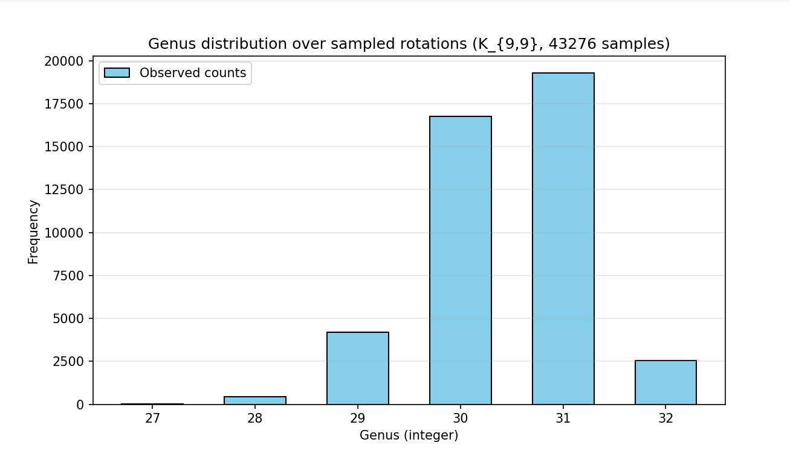
    - 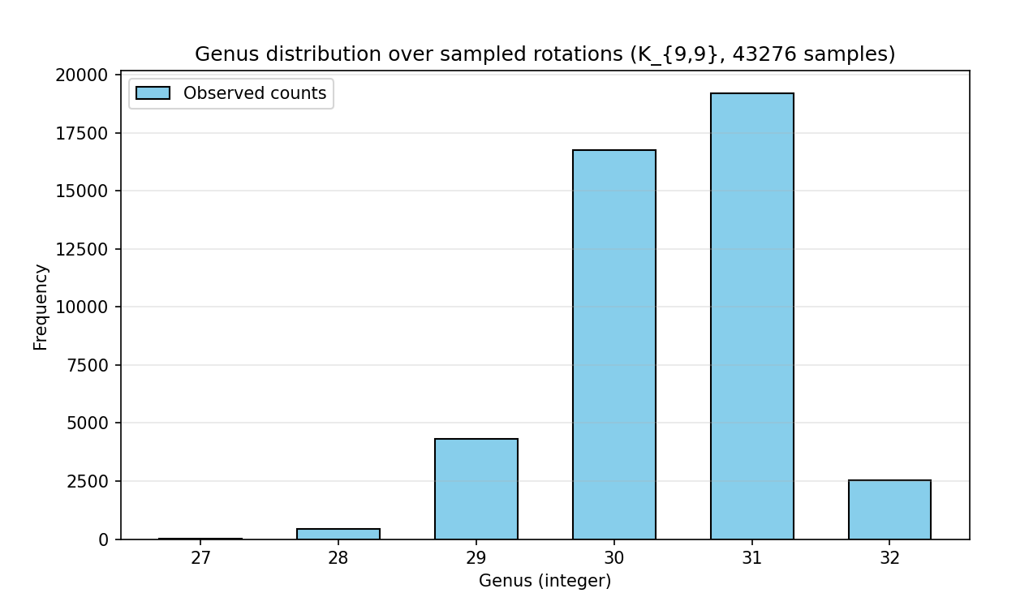
    - 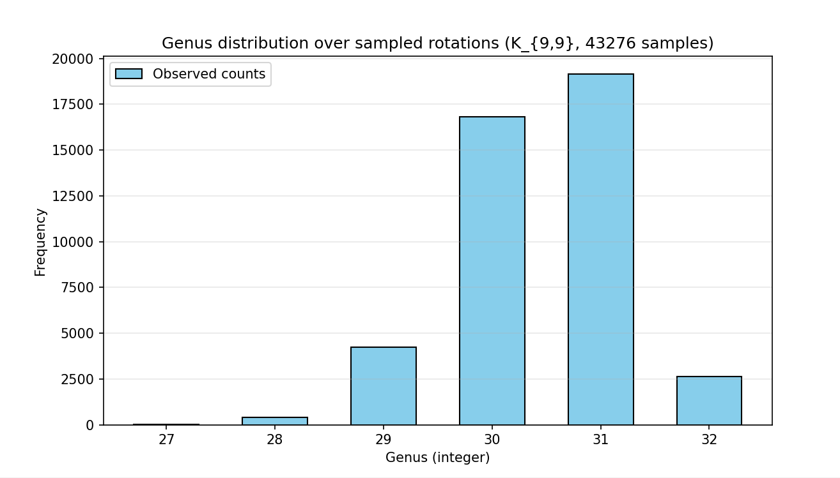
  - Vertex 2 swap
    - single-vertex 2-swap method failed to find optimal solution (found 15.0, expected 13)
    - single-vertex 2-swap method failed to find optimal solution (found 15.0, expected 13).
    - single-vertex 2-swap method failed to find optimal solution (found 15.0, expected 13).
  - Vertex segment reversal
    - segment reversal method failed to find optimal solution (found 18.0, expected 13).
    - segment reversal method failed to find optimal solution (found 16.0, expected 13).
    - segment reversal method failed to find optimal solution (found 16.0, expected 13).
  - Vertex edge moving
    - edge-targeted dart method failed to find optimal solution (found 19.0, expected 13).
    - edge-targeted dart method failed to find optimal solution (found 18.0, expected 13).
    - edge-targeted dart method failed to find optimal solution (found 17.0, expected 13).
  - Vertex full shuffle
    - full-vertex shuffle method failed to find optimal solution (found 18.0, expected 13).
    - full-vertex shuffle method failed to find optimal solution (found 18.0, expected 13).
    - full-vertex shuffle method failed to find optimal solution (found 20.0, expected 13).
  - Multi-neighborhood
    - Multi-neighborhood (weighted) method failed to find optimal solution (found 15.0, expected 13).
    - Found optimal (g=13)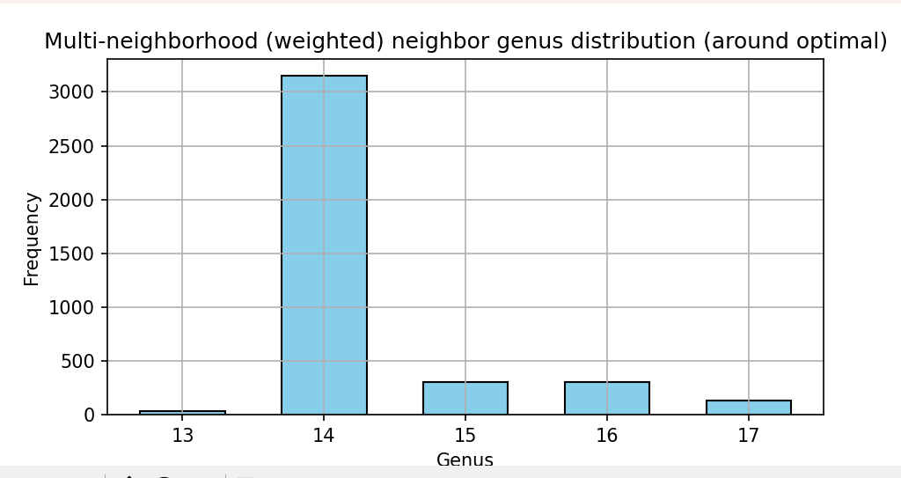
    - Multi-neighborhood (weighted) method failed to find optimal solution (found 14.0, expected 13).

- 3 runs of K(11,11)
  - True Genus of 21
  - Solution space genus distribution
    - 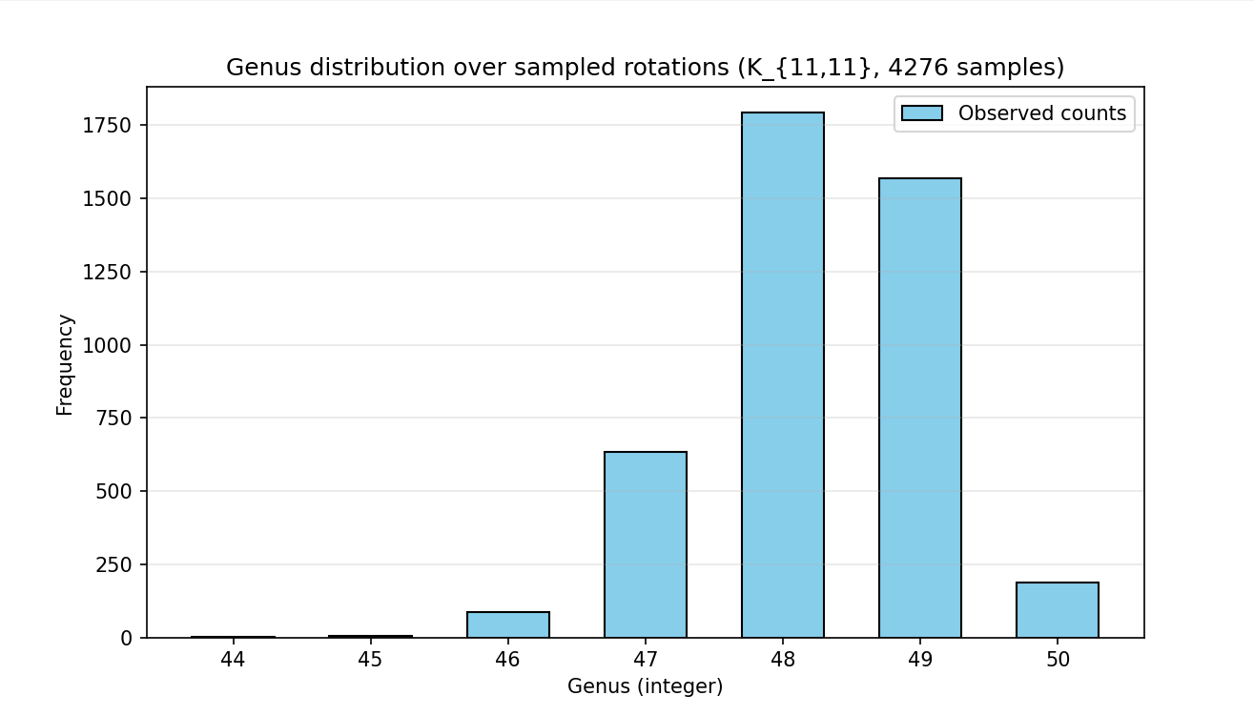
    - 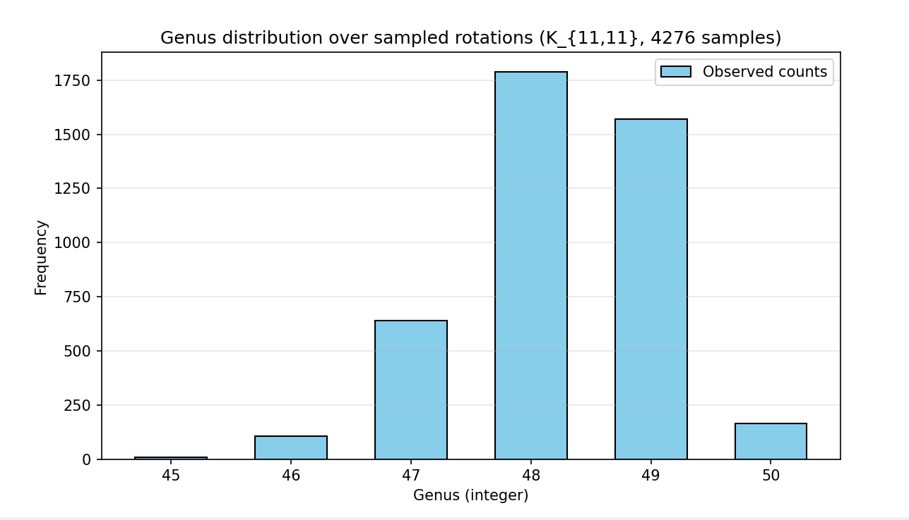
    - 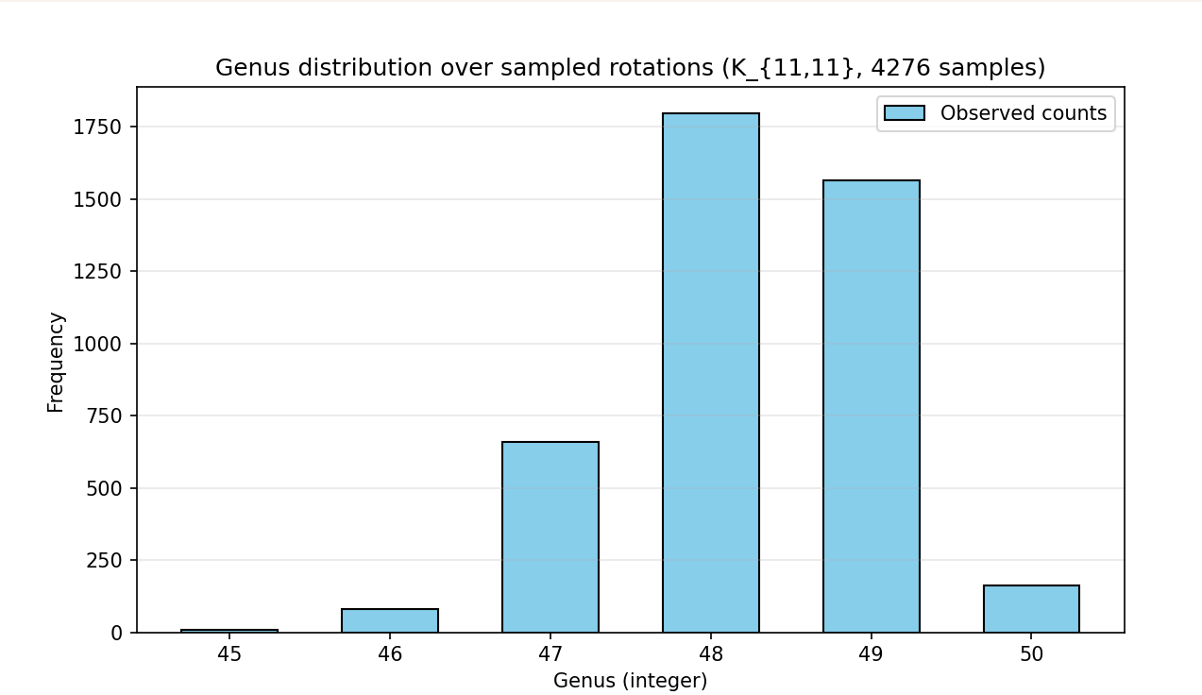
  - Vertex 2 swap
    - single-vertex 2-swap method failed to find optimal solution (found 25.0, expected 21).
    - single-vertex 2-swap method failed to find optimal solution (found 27.0, expected 21).
    - single-vertex 2-swap method failed to find optimal solution (found 25.0, expected 21).
  - Vertex segment reversal
    - segment reversal method failed to find optimal solution (found 30.0, expected 21).
    - segment reversal method failed to find optimal solution (found 26.0, expected 21).
    - segment reversal method failed to find optimal solution (found 28.0, expected 21).
  - Vertex edge moving
    - edge-targeted dart method failed to find optimal solution (found 28.0, expected 21).
    - edge-targeted dart method failed to find optimal solution (found 30.0, expected 21).
    - edge-targeted dart method failed to find optimal solution (found 31.0, expected 21).
  - Vertex full shuffle
    - full-vertex shuffle method failed to find optimal solution (found 36.0, expected 21).
    - full-vertex shuffle method failed to find optimal solution (found 34.0, expected 21).
    - full-vertex shuffle method failed to find optimal solution (found 35.0, expected 21).
  - Multi-neighborhood
    - Multi-neighborhood (weighted) method failed to find optimal solution (found 26.0, expected 21).
    - Multi-neighborhood (weighted) method failed to find optimal solution (found 27.0, expected 21).
    - Multi-neighborhood (weighted) method failed to find optimal solution (found 26.0, expected 21).

- 3 runs of K(13,13)
  - True Genus of 31
  - Solution space genus distribution

  - Vertex 2 swap

  - Vertex segment reversal

  - Vertex edge moving

  - Vertex full shuffle

  - Multi-neighborhood

- 3 runs of K(14,14)
  - True Genus of 21
  - Solution space genus distribution

  - Vertex 2 swap

  - Vertex segment reversal

  - Vertex edge moving

  - Vertex full shuffle

  - Multi-neighborhood

Genus Distribution of 5 different rotations of K(4,4)
- Rotation #1 (g=4)
vertex 0: [4, 7, 5, 6]
vertex 1: [4, 7, 6, 5]
vertex 2: [4, 7, 6, 5]
vertex 3: [4, 7, 5, 6]
vertex 4: [0, 3, 2, 1]
vertex 5: [0, 1, 2, 3]
vertex 6: [0, 2, 1, 3]
vertex 7: [0, 2, 1, 3]
  - 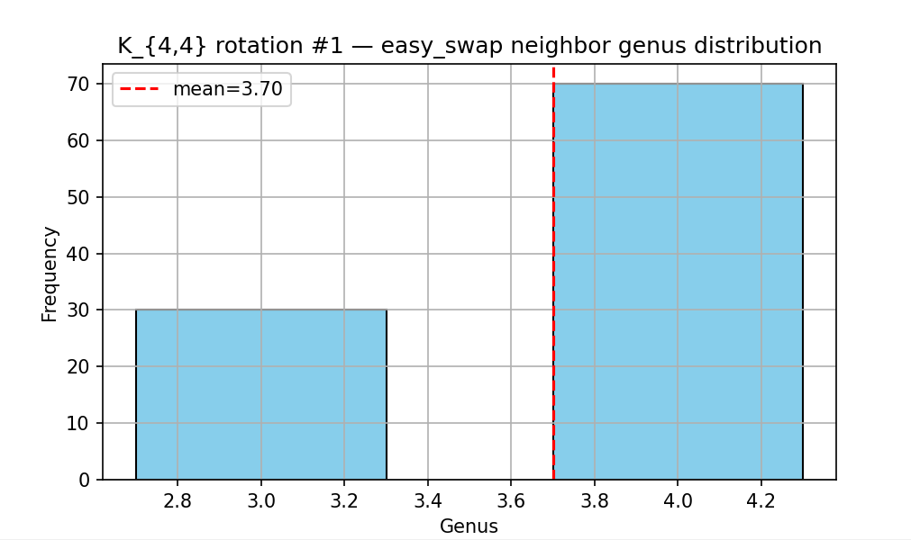
  - 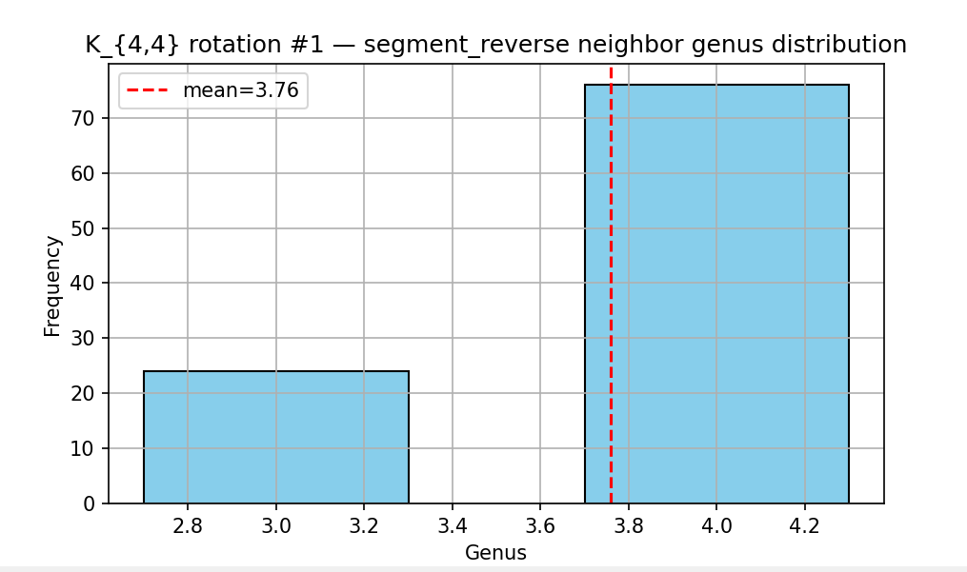
  - 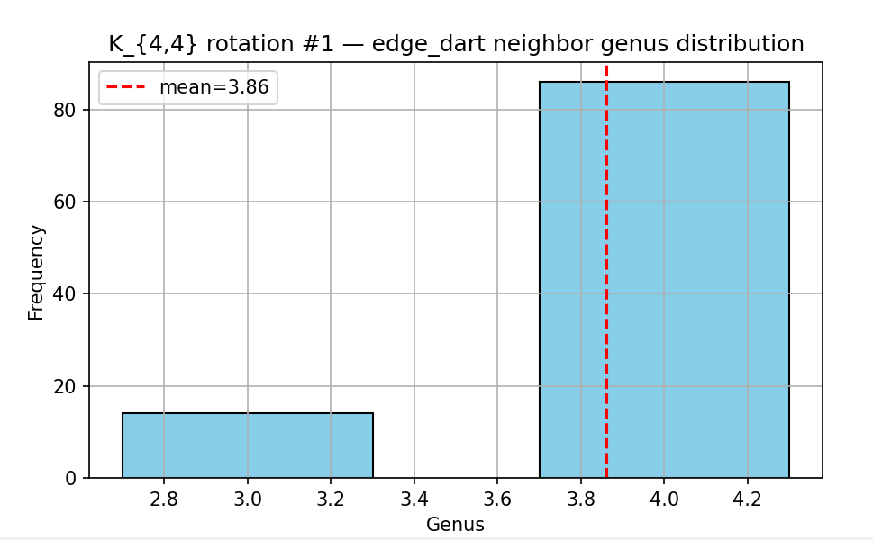
  - 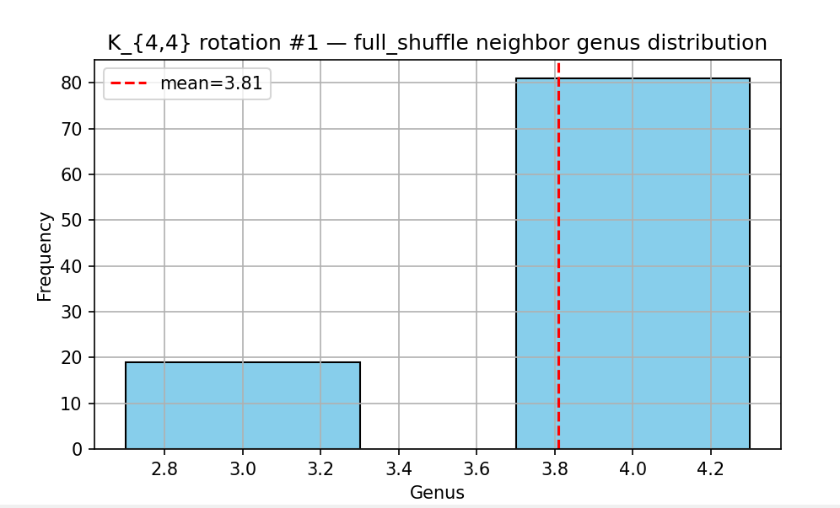
  - 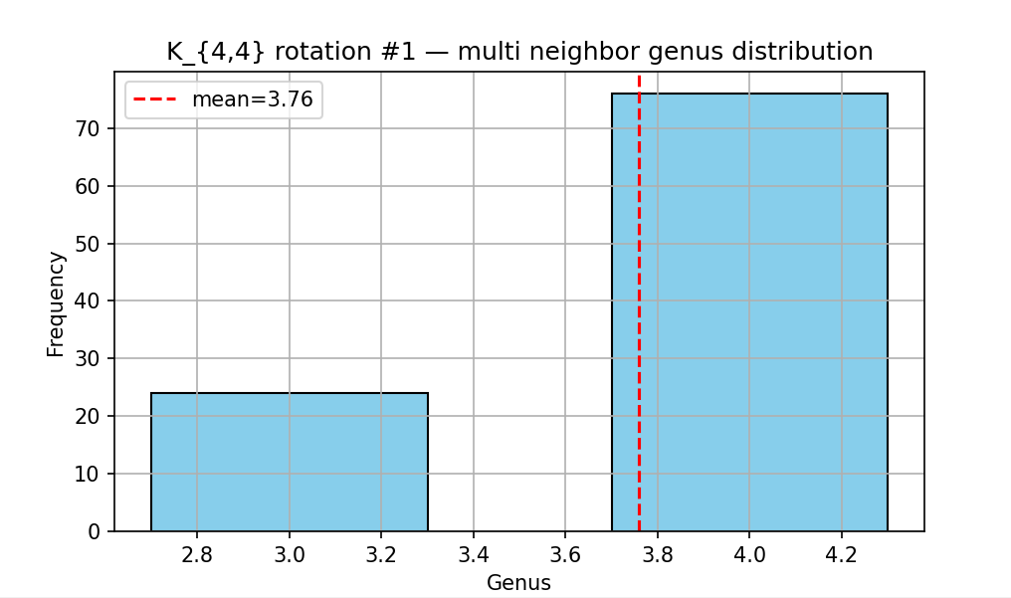

- Rotation 2 (g =4)
  - vertex 0: [4, 5, 7, 6]
vertex 1: [4, 7, 5, 6]
vertex 2: [4, 7, 6, 5]
vertex 3: [4, 5, 7, 6]
vertex 4: [0, 1, 2, 3]
vertex 5: [0, 1, 2, 3]
vertex 6: [0, 1, 3, 2]
vertex 7: [0, 2, 1, 3]
  - 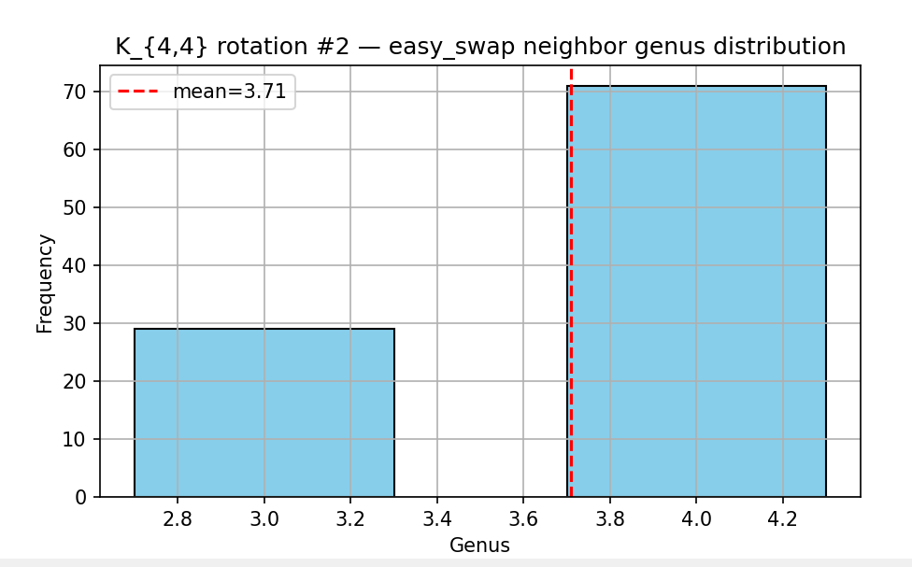
  - 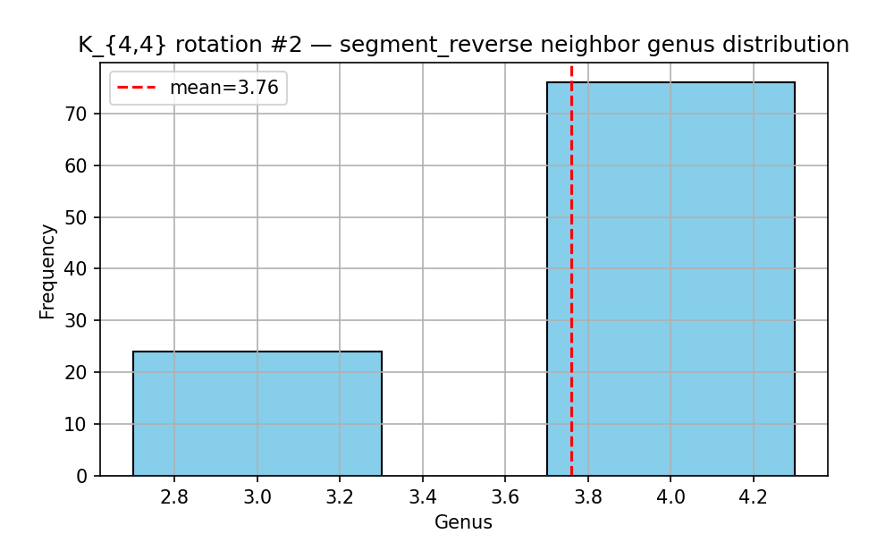
  - 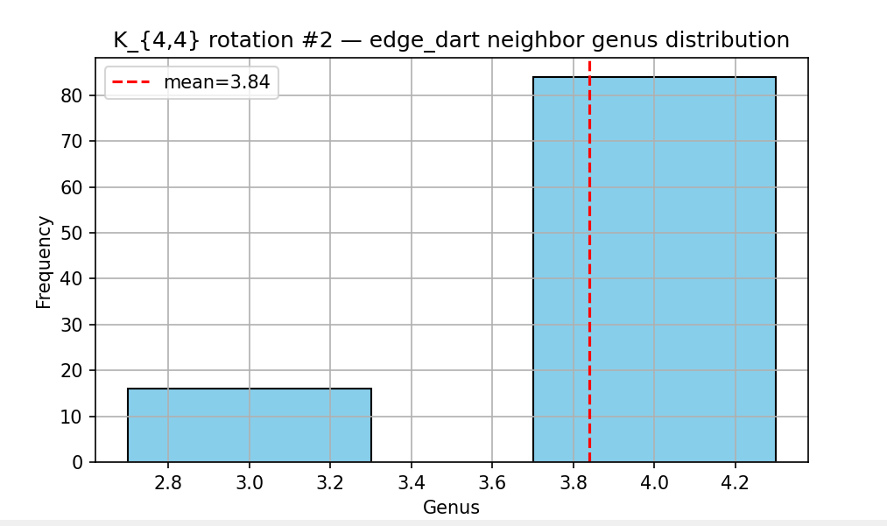
  - 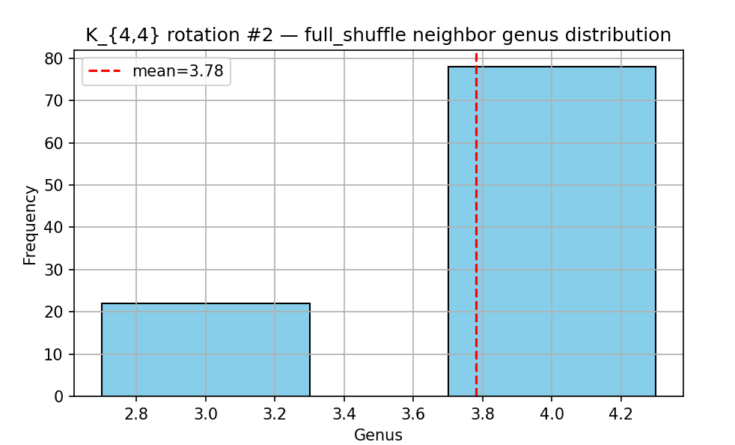
  - 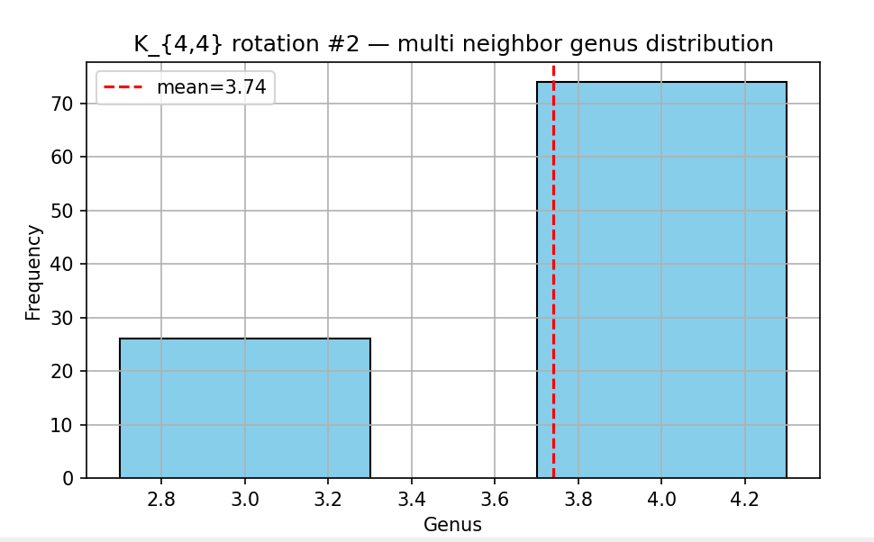

- Rotation 3 (g=3)
  - vertex 0: [4, 6, 5, 7]
vertex 1: [4, 7, 6, 5]
vertex 2: [4, 7, 6, 5]
vertex 3: [4, 7, 6, 5]
vertex 4: [0, 1, 3, 2]
vertex 5: [0, 3, 1, 2]
vertex 6: [0, 1, 3, 2]
vertex 7: [0, 3, 1, 2]
  - 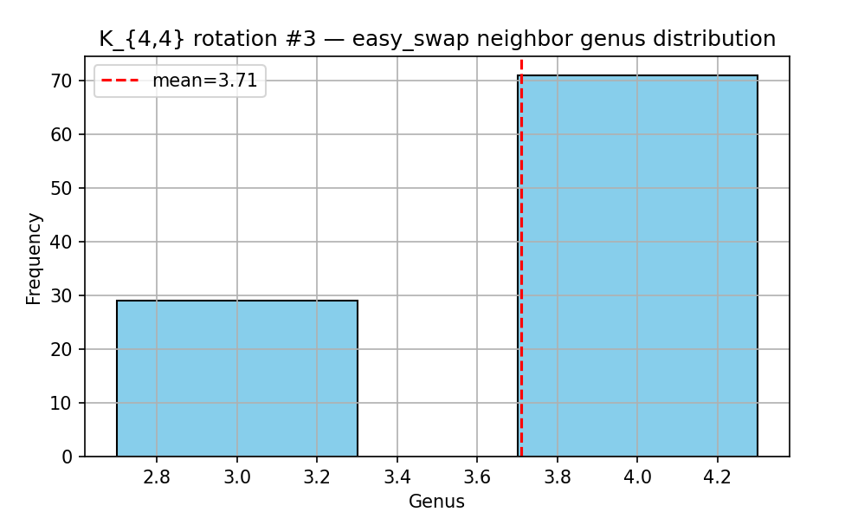
  - 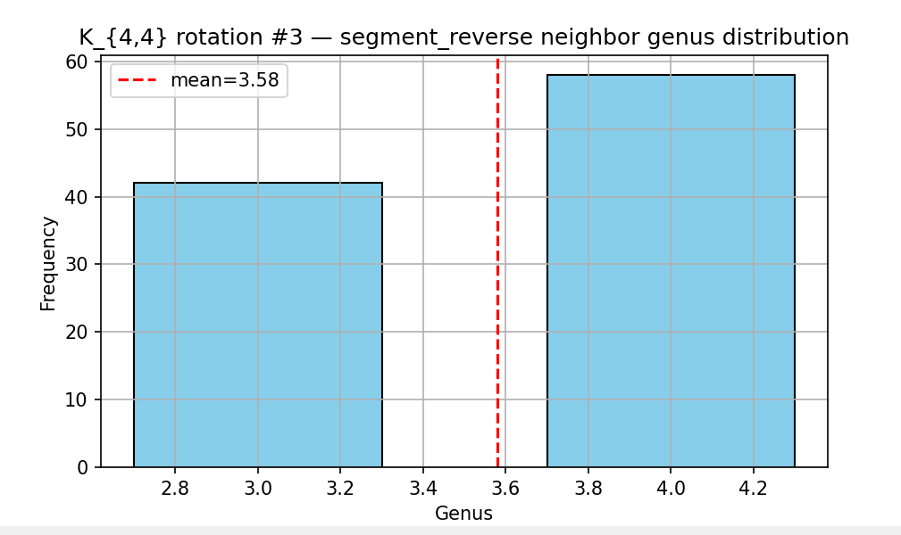
  - 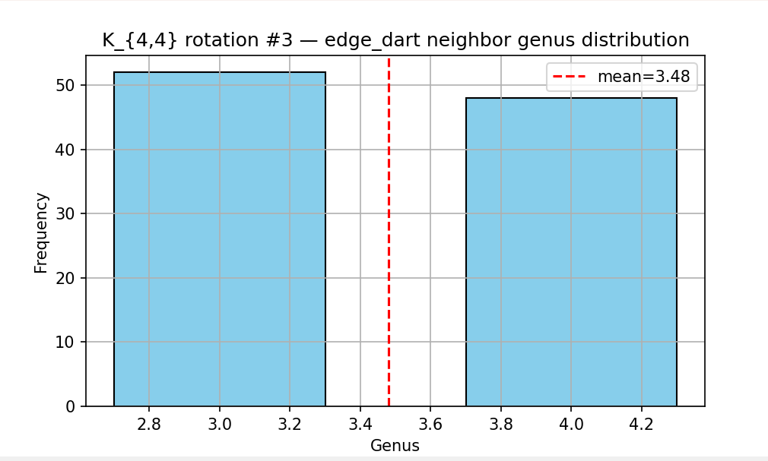
  - 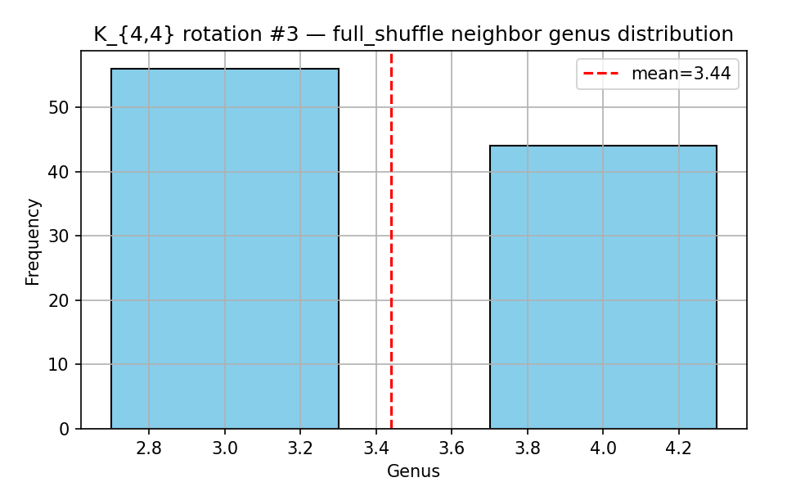
  - 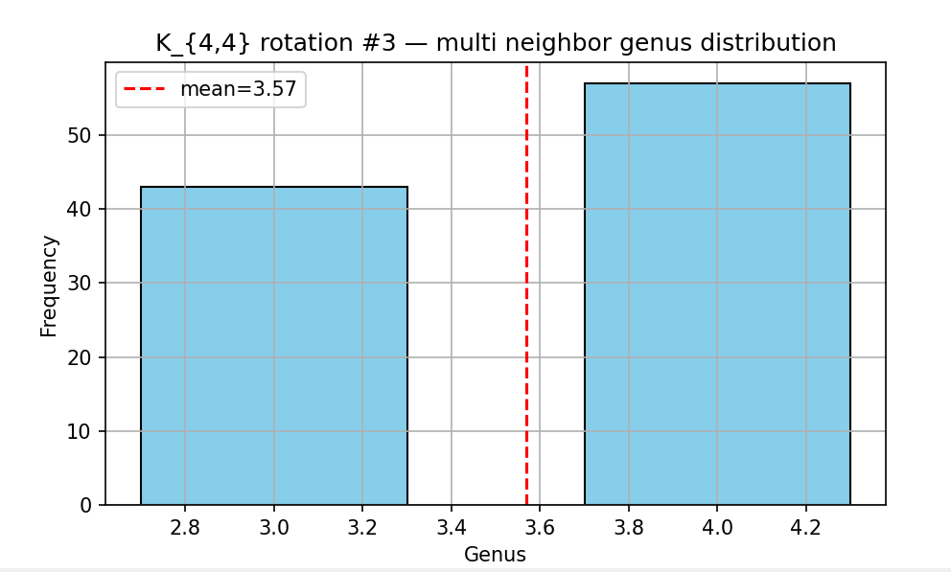

- Rotation #4 (genus=4.0)
  - vertex 0: [4, 5, 7, 6]
vertex 1: [4, 5, 6, 7]
vertex 2: [4, 6, 5, 7]
vertex 3: [4, 5, 6, 7]
vertex 4: [0, 2, 3, 1]
vertex 5: [0, 1, 3, 2]
vertex 6: [0, 3, 2, 1]
vertex 7: [0, 3, 1, 2]
  - 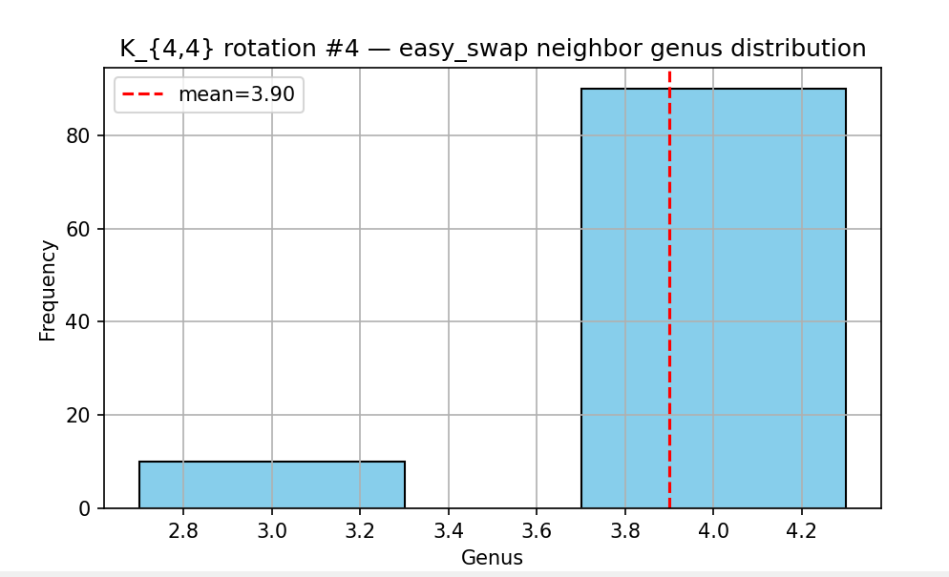
  - 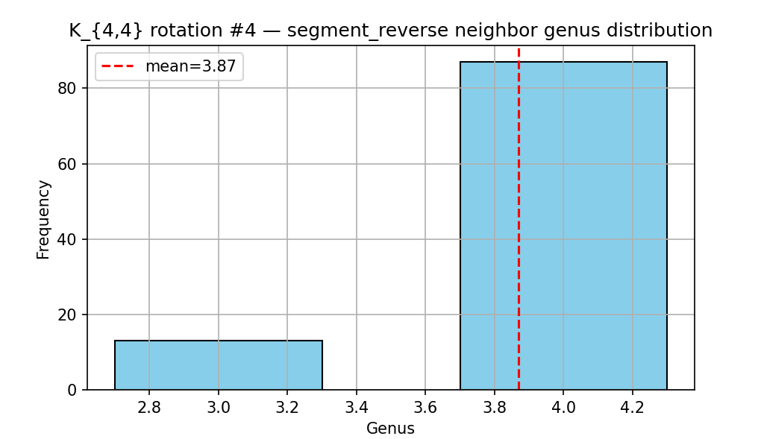
  - 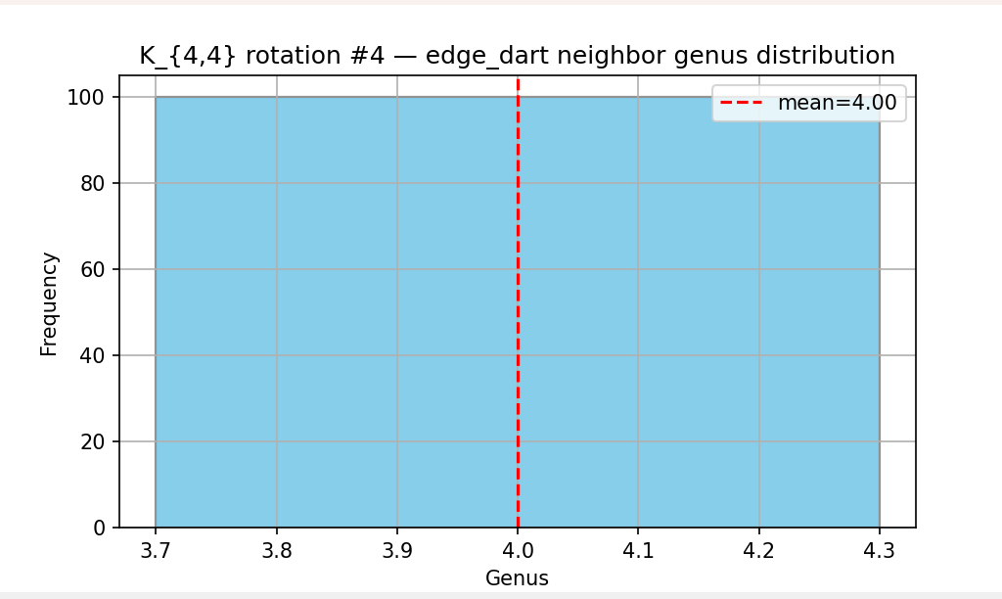
  - 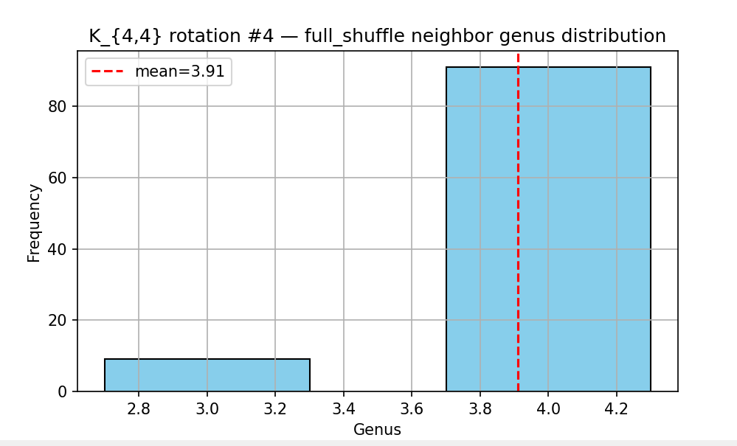
  - 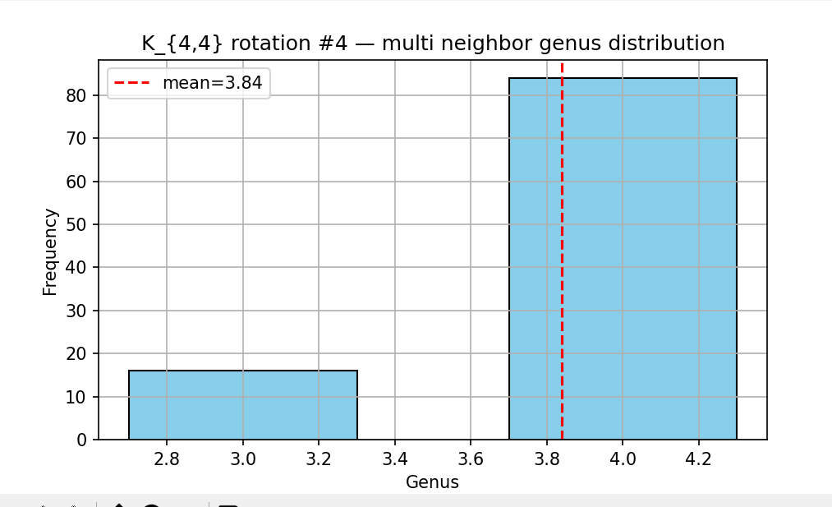

- Rotation 5 (g=4)
- I AM STUPID!

K(4,4) true genus = 1
- Rotation 1 (g=4)
  - vertex 0: [4, 6, 5, 7]
vertex 1: [4, 7, 6, 5]
vertex 2: [4, 6, 5, 7]
vertex 3: [4, 5, 7, 6]
vertex 4: [0, 3, 1, 2]
vertex 5: [0, 3, 2, 1]
vertex 6: [0, 2, 1, 3]
vertex 7: [0, 1, 3, 2]
  - 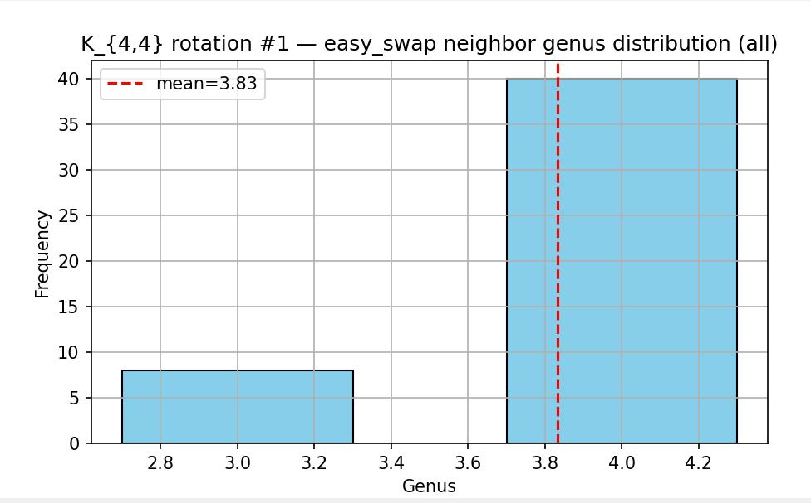
  - 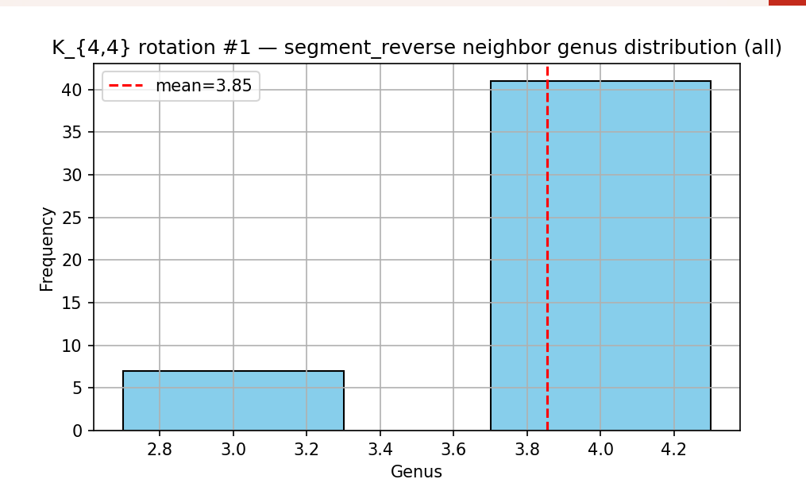
  - 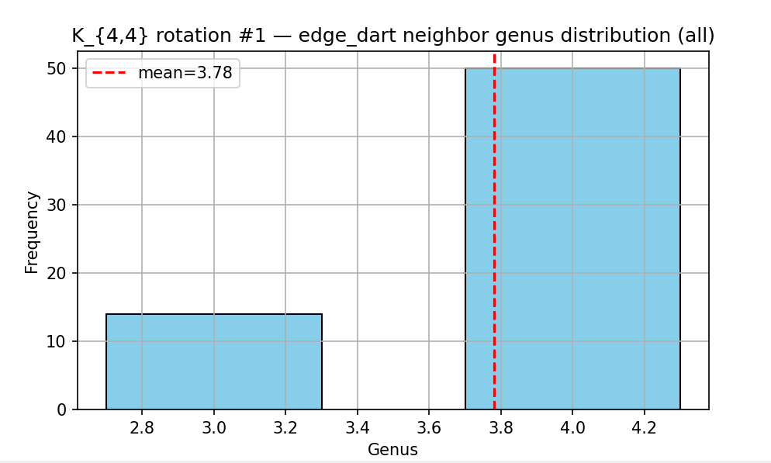
  - 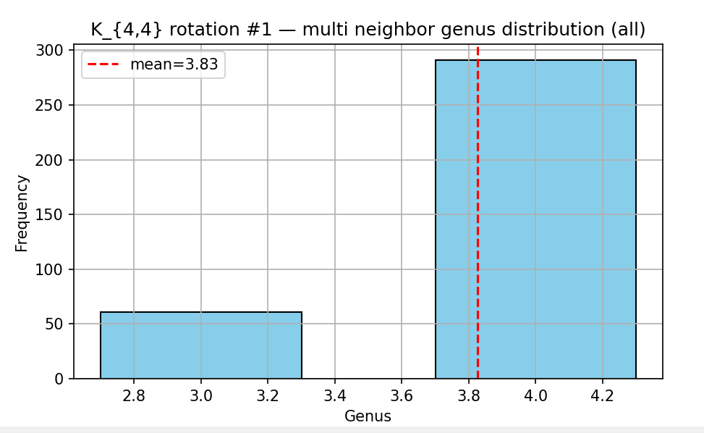
- Rotation 2 (g=4)
  - vertex 0: [4, 6, 5, 7]
vertex 1: [4, 7, 6, 5]
vertex 2: [4, 7, 6, 5]
vertex 3: [4, 6, 7, 5]
vertex 4: [0, 3, 2, 1]
vertex 5: [0, 2, 1, 3]
vertex 6: [0, 3, 1, 2]
vertex 7: [0, 1, 3, 2]
  - 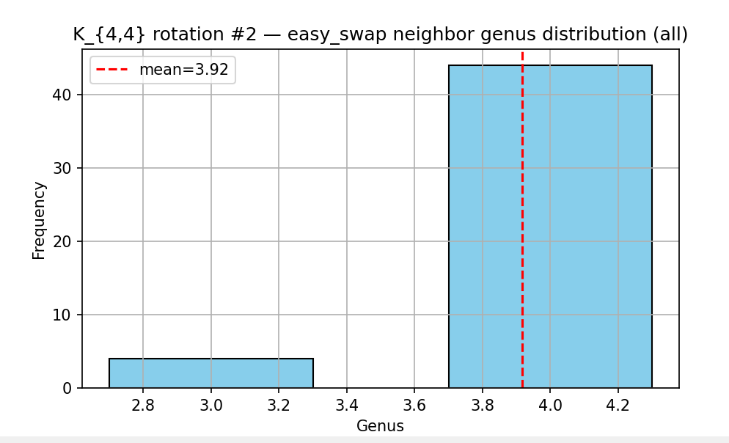

  - 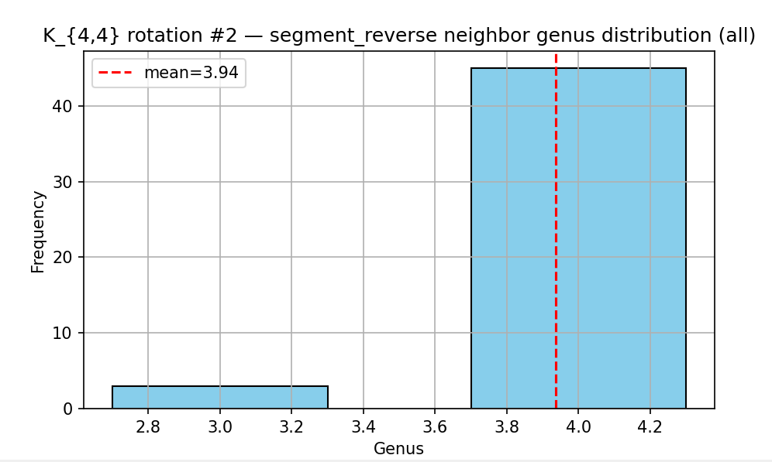
  - 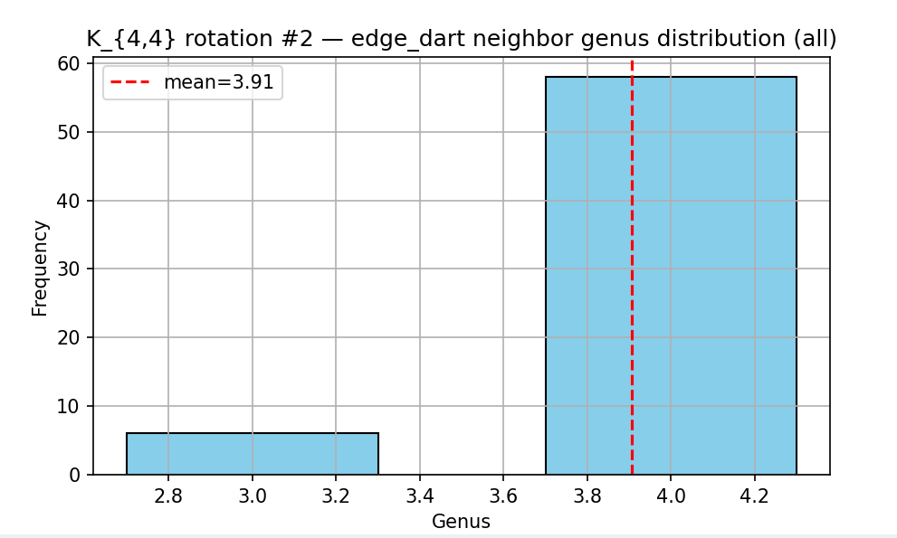

  - 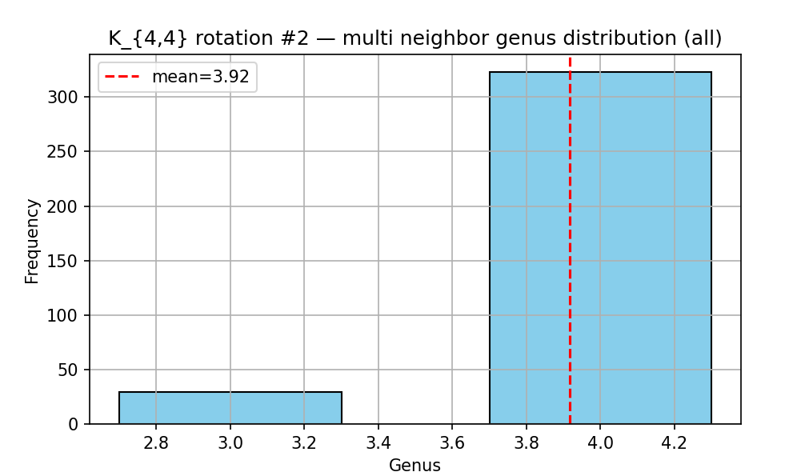

- Rotation 3 (g=4 )
  - vertex 0: [4, 5, 6, 7]
vertex 1: [4, 6, 5, 7]
vertex 2: [4, 6, 7, 5]
vertex 3: [4, 6, 7, 5]
vertex 4: [0, 3, 2, 1]
vertex 5: [0, 2, 1, 3]
vertex 6: [0, 1, 2, 3]
vertex 7: [0, 1, 3, 2]
  - 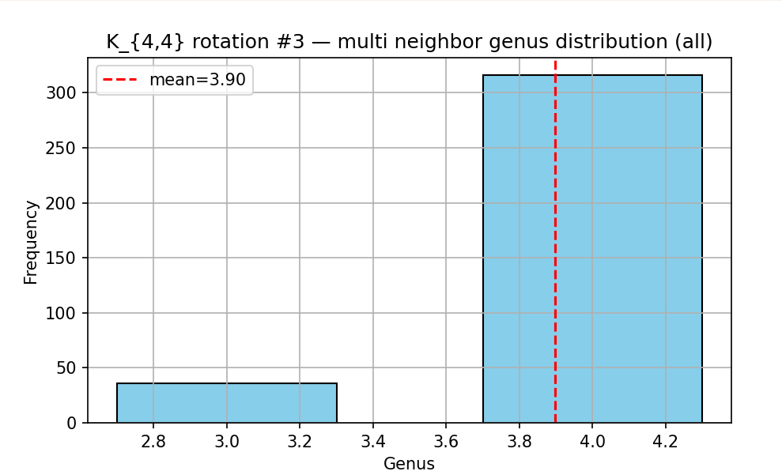
  - 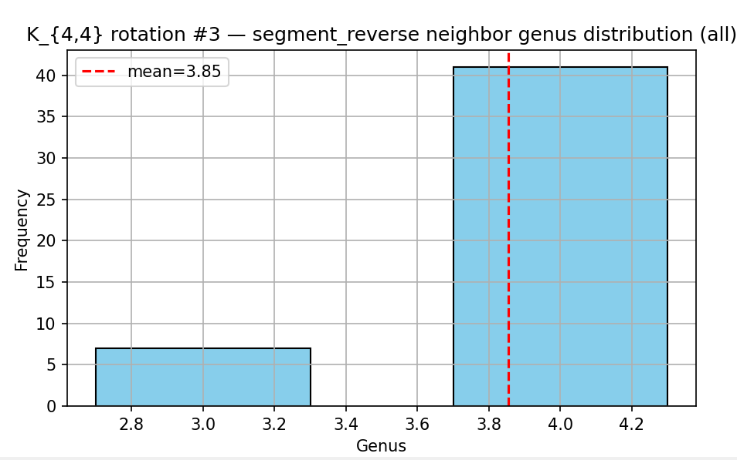
  - 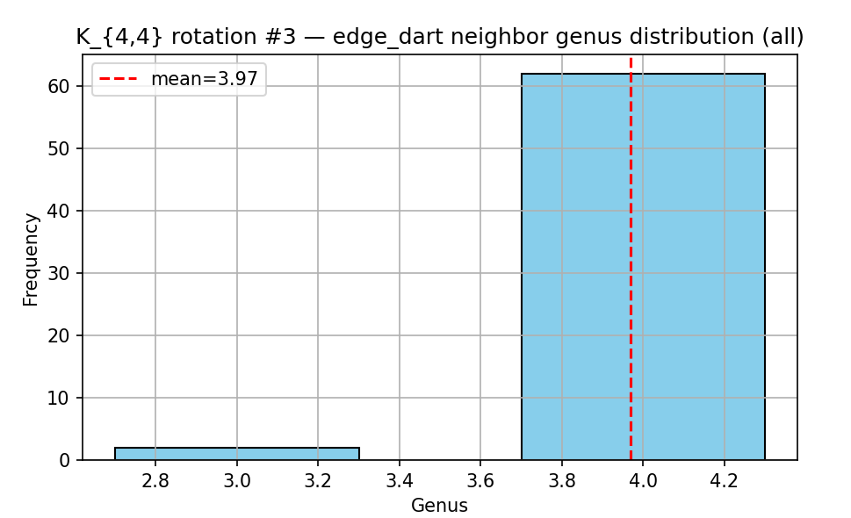
  - 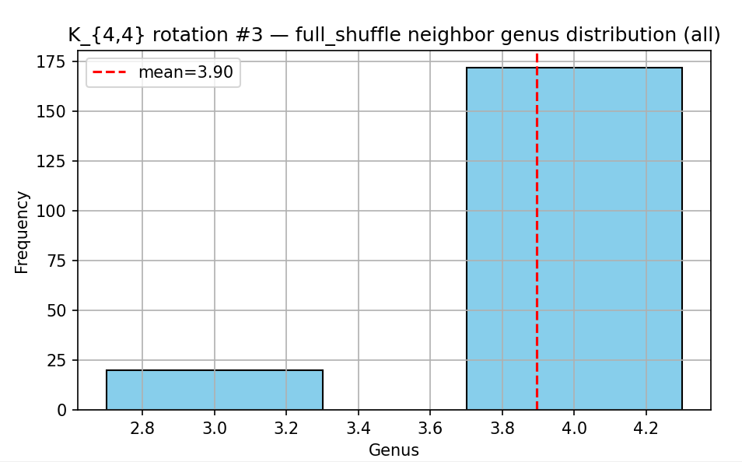
  - 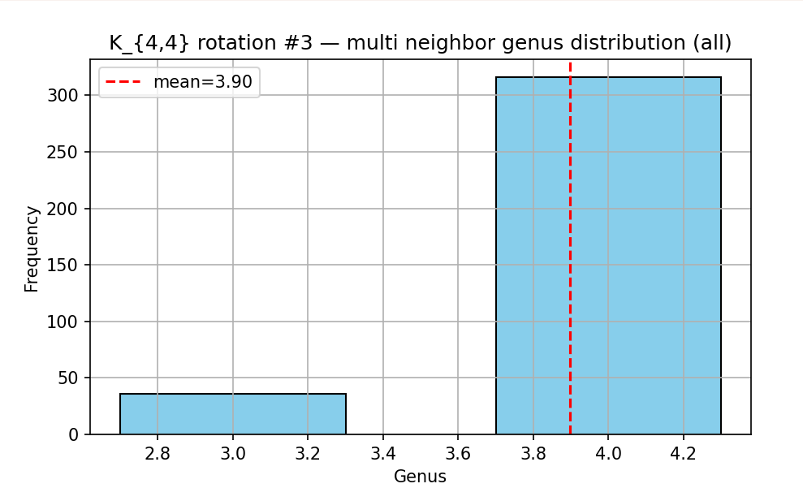

3 rotations of K(5,5), True genus 3
- Rotation 1 (g=7)
  - vertex 0: [5, 6, 7, 8, 9]
vertex 1: [5, 8, 7, 9, 6]
vertex 2: [5, 8, 7, 9, 6]
vertex 3: [5, 7, 9, 8, 6]
vertex 4: [5, 8, 7, 6, 9]
vertex 5: [0, 3, 4, 1, 2]
vertex 6: [0, 2, 3, 4, 1]
vertex 7: [0, 3, 1, 2, 4]
vertex 8: [0, 1, 3, 4, 2]
vertex 9: [0, 1, 3, 2, 4]
  - 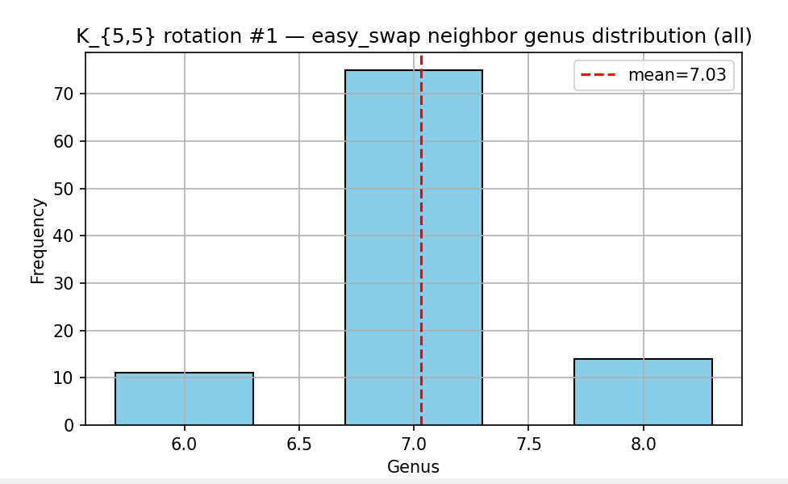
  - 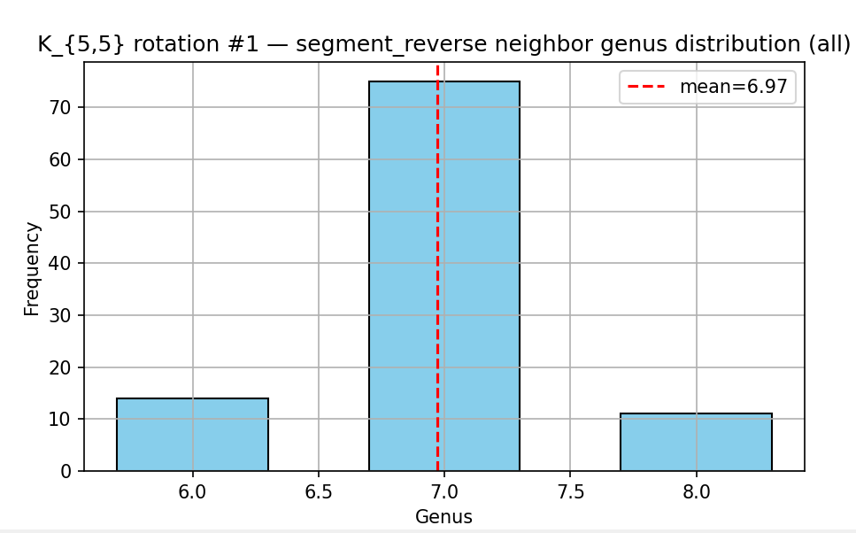
  - 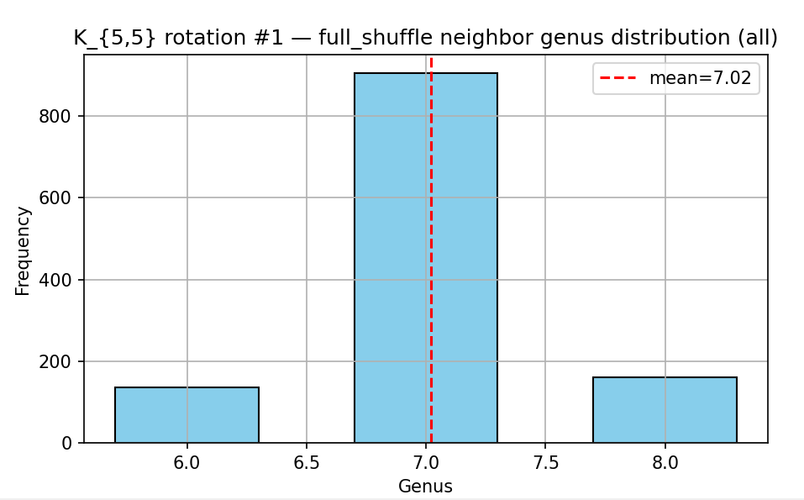
  - 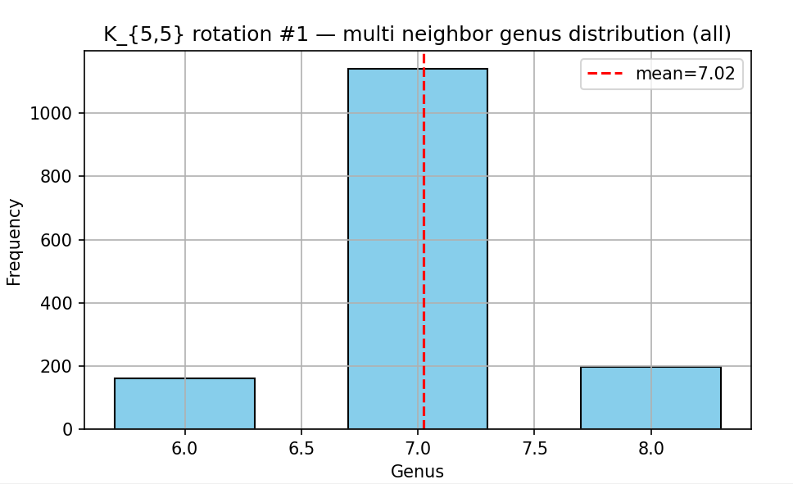
- Rotation 2 (g=6)
  - vertex 0: [5, 6, 8, 9, 7]
vertex 1: [5, 6, 9, 7, 8]
vertex 2: [5, 8, 7, 6, 9]
vertex 3: [5, 7, 8, 9, 6]
vertex 4: [5, 8, 7, 9, 6]
vertex 5: [0, 4, 2, 1, 3]
vertex 6: [0, 2, 4, 1, 3]
vertex 7: [0, 1, 3, 2, 4]
vertex 8: [0, 2, 1, 3, 4]
vertex 9: [0, 1, 4, 2, 3]
  - 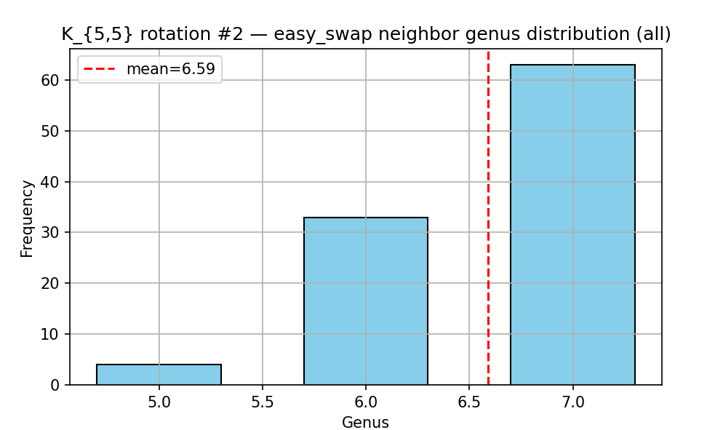
  - 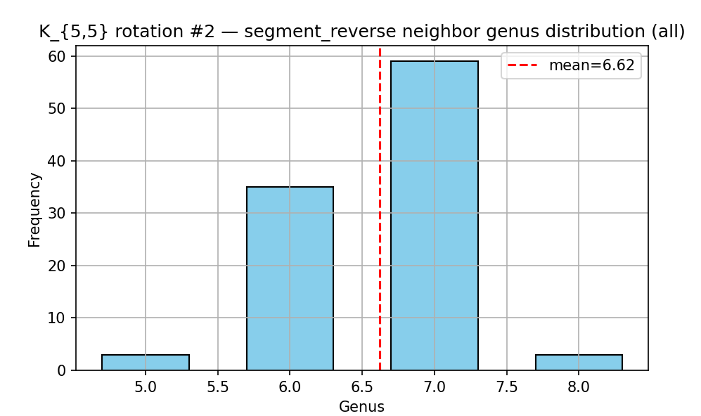
  - 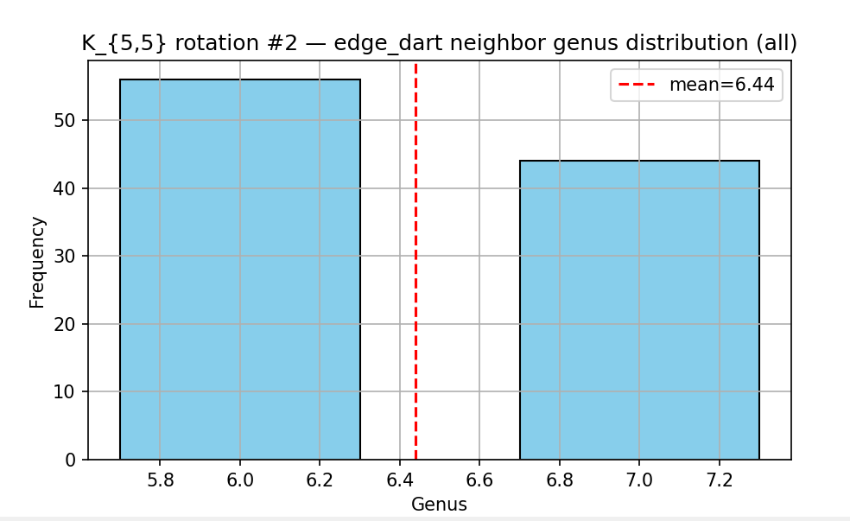
  - 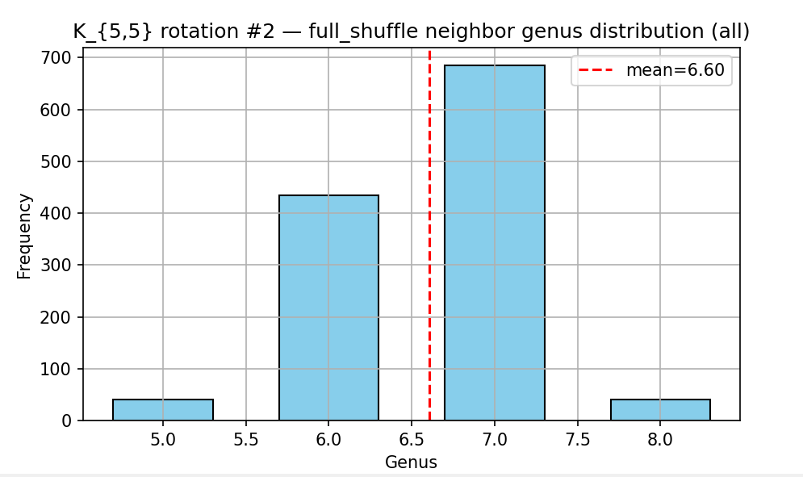
  - 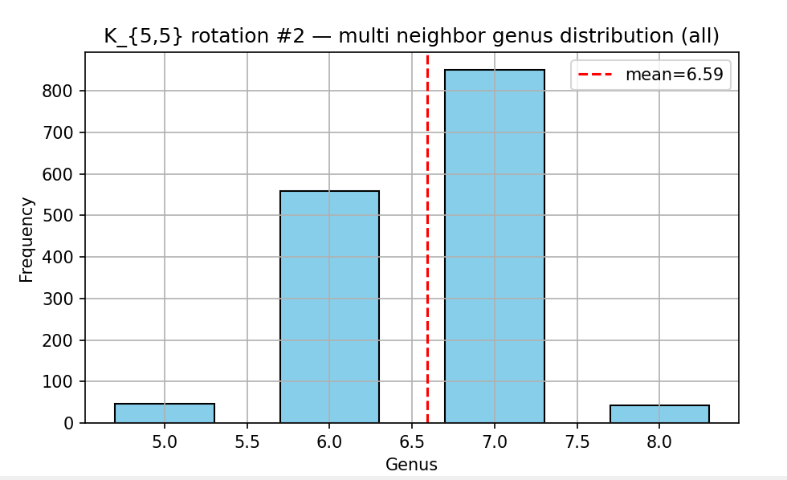
- Rotation 3 (g=7)
  - vertex 0: [5, 8, 7, 6, 9]
vertex 1: [5, 9, 8, 7, 6]
vertex 2: [5, 6, 7, 8, 9]
vertex 3: [5, 7, 8, 9, 6]
vertex 4: [5, 8, 6, 7, 9]
vertex 5: [0, 2, 1, 4, 3]
vertex 6: [0, 1, 4, 2, 3]
vertex 7: [0, 1, 4, 2, 3]
vertex 8: [0, 4, 2, 1, 3]
vertex 9: [0, 3, 1, 4, 2]
  - 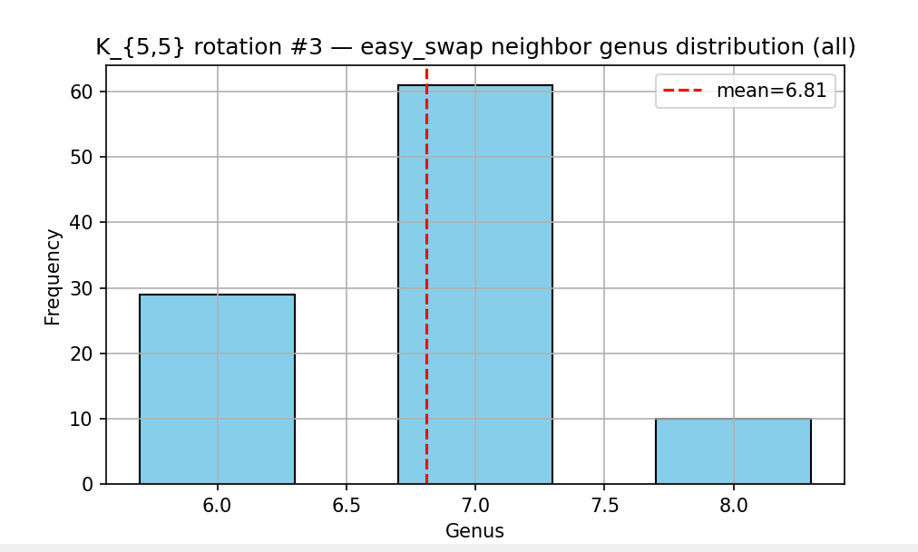
  - 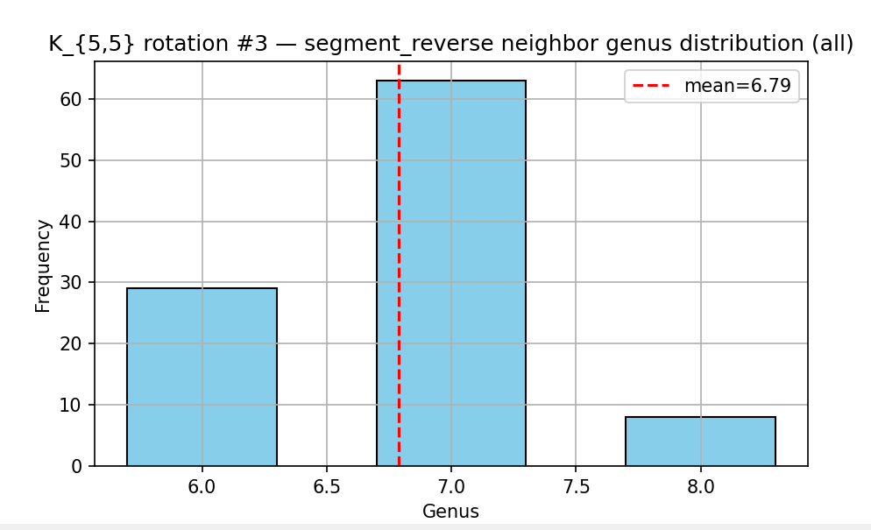
  - 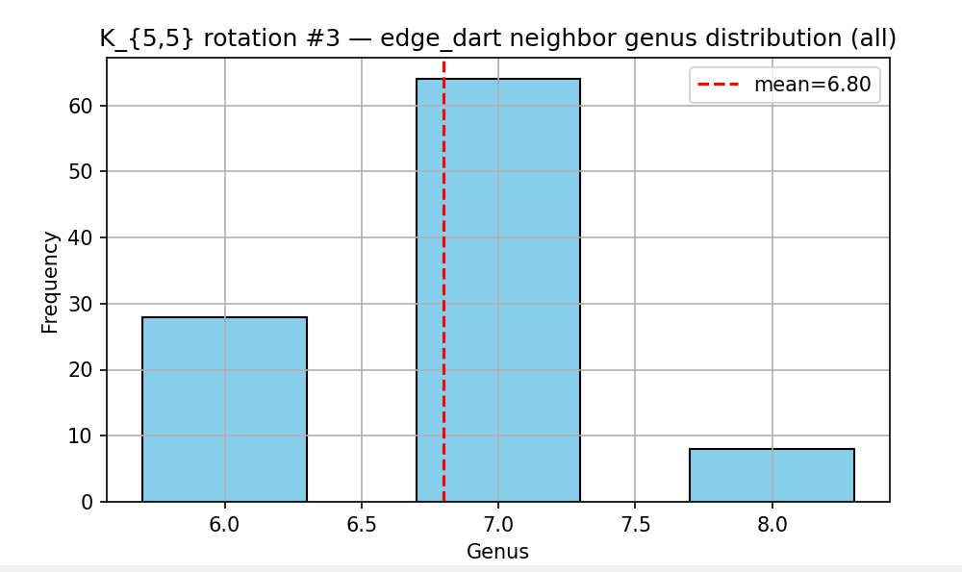
  - 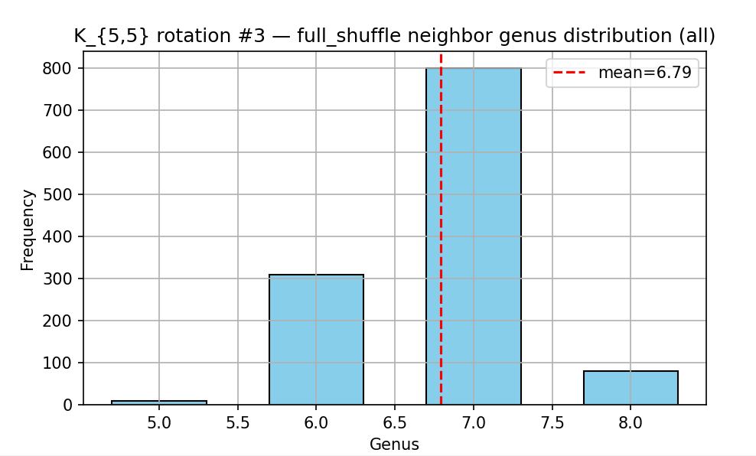
  - 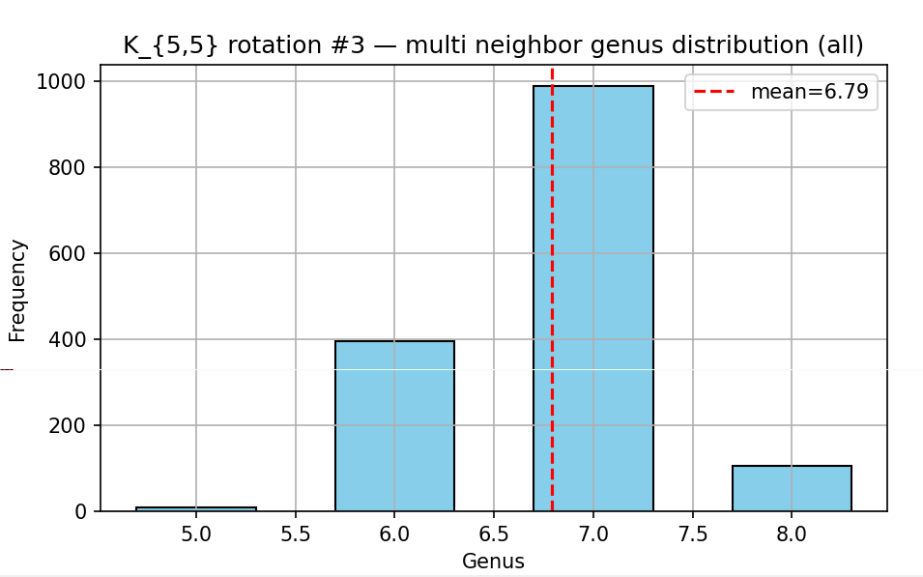

3 rotations of k(6,6)
- Rotation 1 (g=12)
  - vertex 0: [6, 9, 10, 8, 7, 11]
vertex 1: [6, 7, 8, 10, 11, 9]
vertex 2: [6, 11, 8, 7, 9, 10]
vertex 3: [6, 10, 8, 7, 11, 9]
vertex 4: [6, 8, 9, 10, 7, 11]
vertex 5: [6, 8, 11, 7, 10, 9]
vertex 6: [0, 3, 4, 5, 1, 2]
vertex 7: [0, 4, 5, 3, 2, 1]
vertex 8: [0, 3, 2, 1, 5, 4]
vertex 9: [0, 2, 4, 5, 3, 1]
vertex 10: [0, 4, 5, 1, 3, 2]
vertex 11: [0, 2, 5, 4, 3, 1]
  - 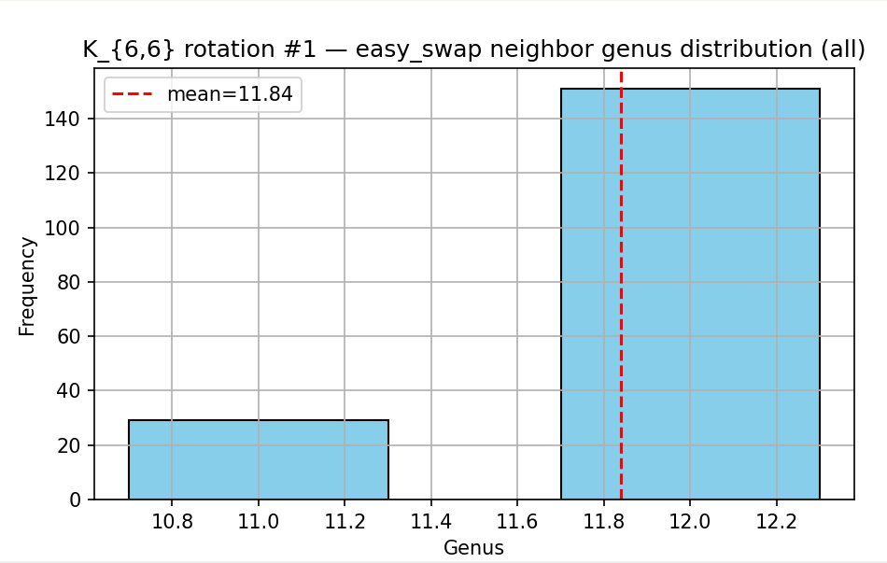
  - 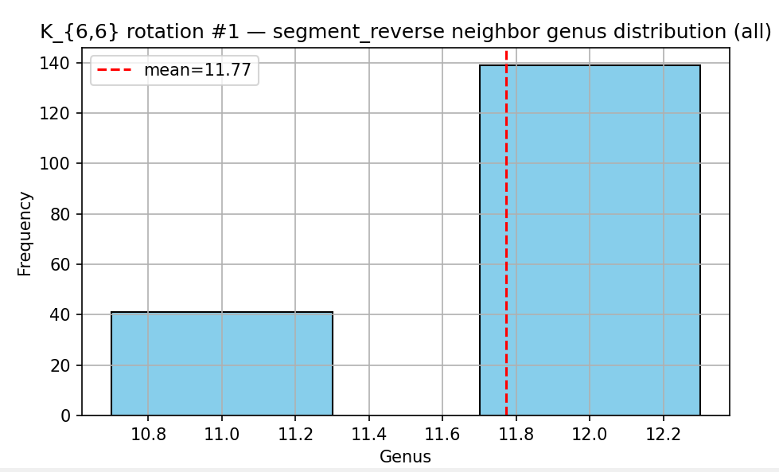
  - 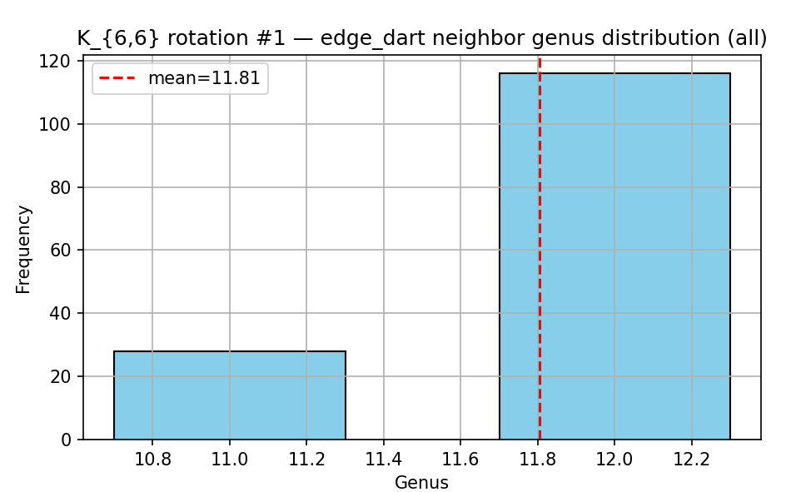
  - 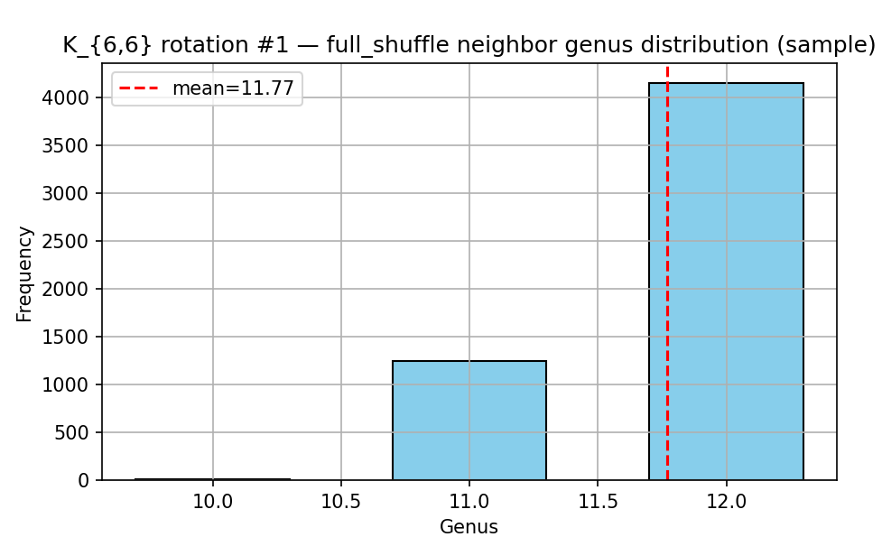
  - 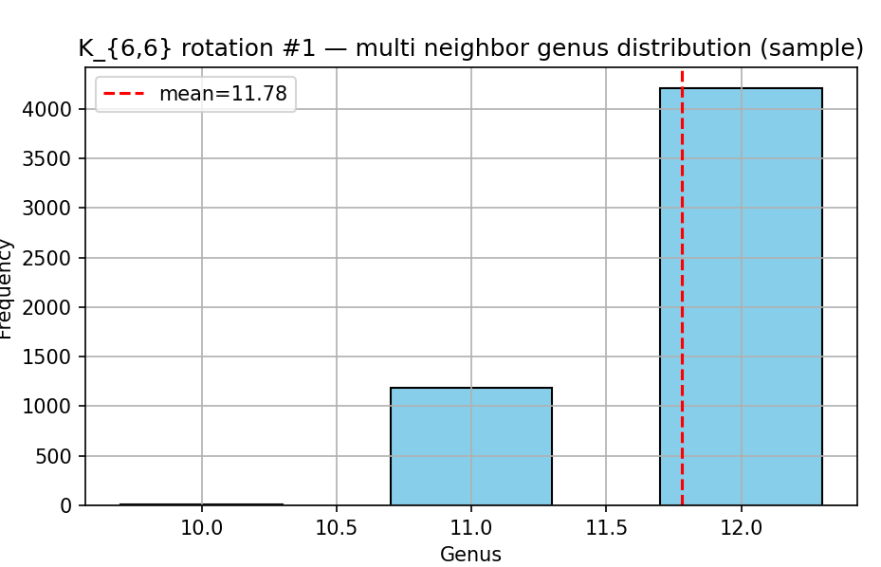

- Rotation 2 (g=12)
  - vertex 0: [6, 10, 8, 9, 7, 11]
vertex 1: [6, 11, 9, 10, 7, 8]
vertex 2: [6, 9, 8, 11, 7, 10]
vertex 3: [6, 8, 11, 7, 10, 9]
vertex 4: [6, 10, 11, 8, 7, 9]
vertex 5: [6, 11, 8, 9, 7, 10]
vertex 6: [0, 5, 4, 2, 3, 1]
vertex 7: [0, 2, 3, 4, 5, 1]
vertex 8: [0, 5, 1, 3, 2, 4]
vertex 9: [0, 4, 3, 1, 5, 2]
vertex 10: [0, 4, 3, 2, 5, 1]
vertex 11: [0, 2, 1, 5, 4, 3]
  - 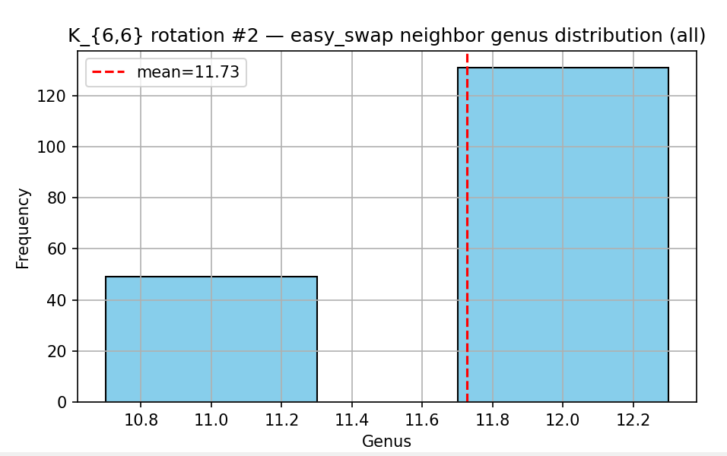
  - 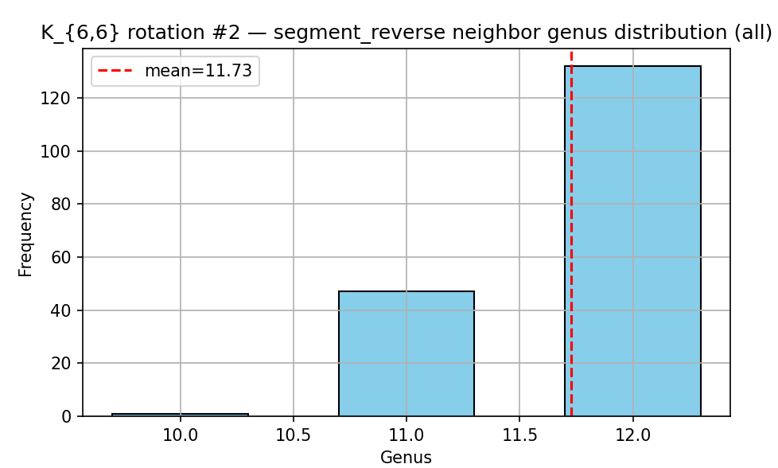
  - 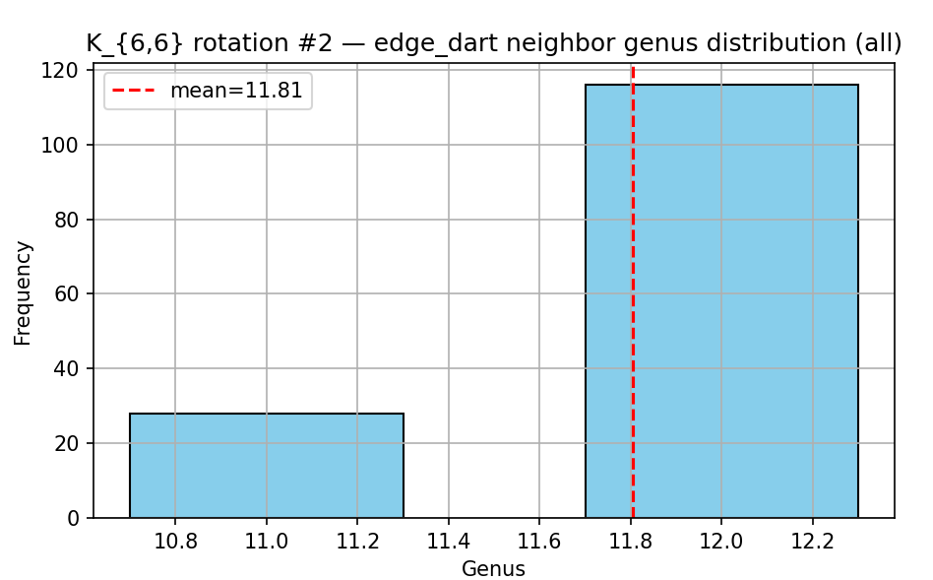
  - 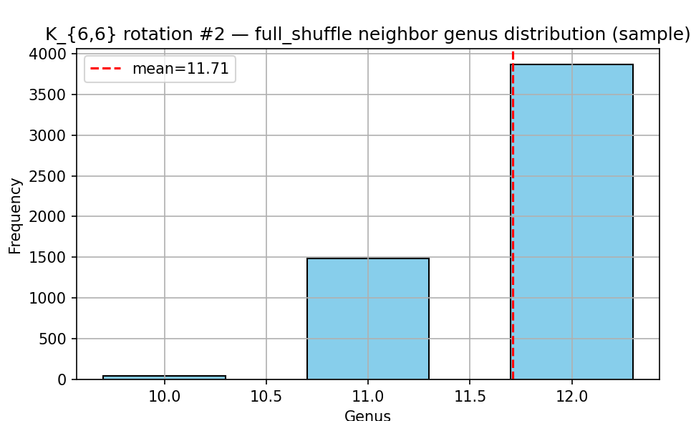
  - 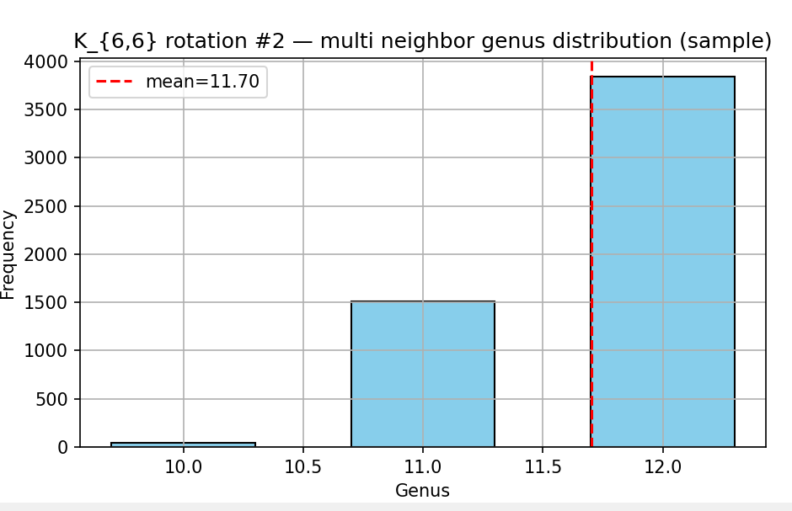

- Rotation 3 (g=12)
  - Vertex 0: [6, 7, 8, 10, 9, 11]
vertex 1: [6, 11, 7, 8, 10, 9]
vertex 2: [6, 8, 7, 10, 11, 9]
vertex 3: [6, 9, 8, 11, 10, 7]
vertex 4: [6, 8, 10, 11, 9, 7]
vertex 5: [6, 10, 7, 9, 11, 8]
vertex 6: [0, 4, 5, 1, 3, 2]
vertex 7: [0, 4, 1, 5, 3, 2]
vertex 8: [0, 4, 5, 2, 1, 3]
vertex 9: [0, 3, 4, 5, 2, 1]
vertex 10: [0, 2, 1, 3, 4, 5]
vertex 11: [0, 1, 3, 5, 2, 4]
  - 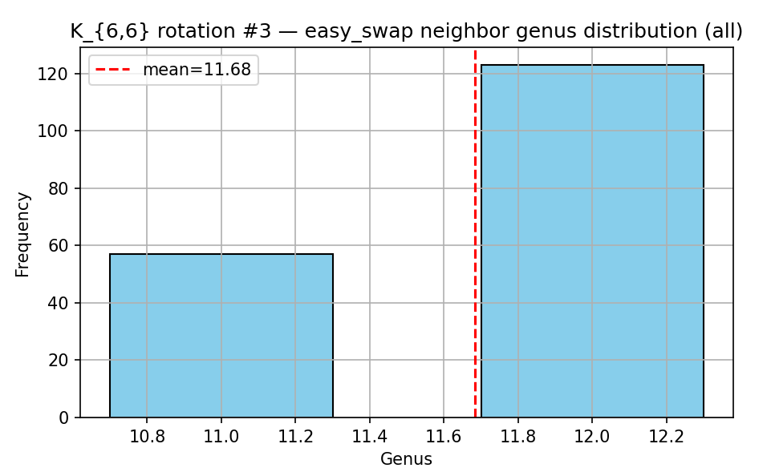
  - 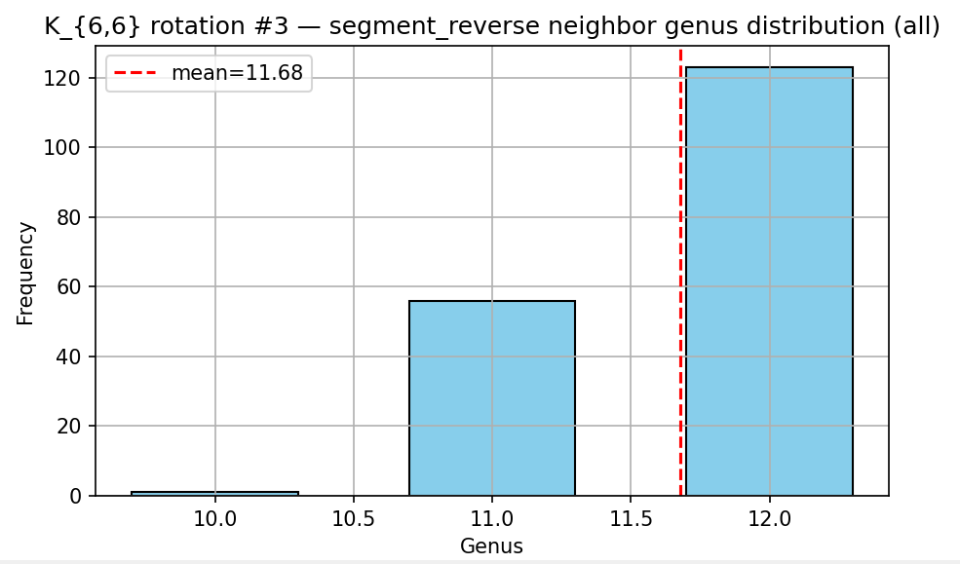
  - 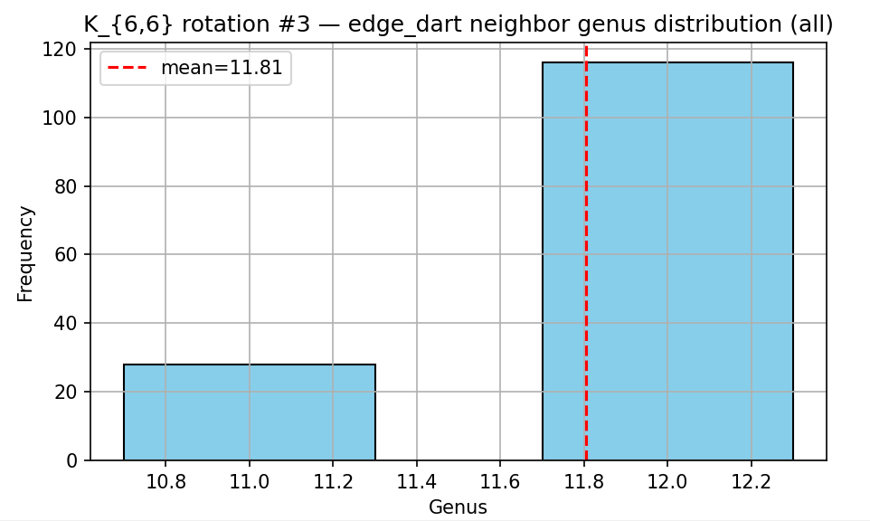
  - 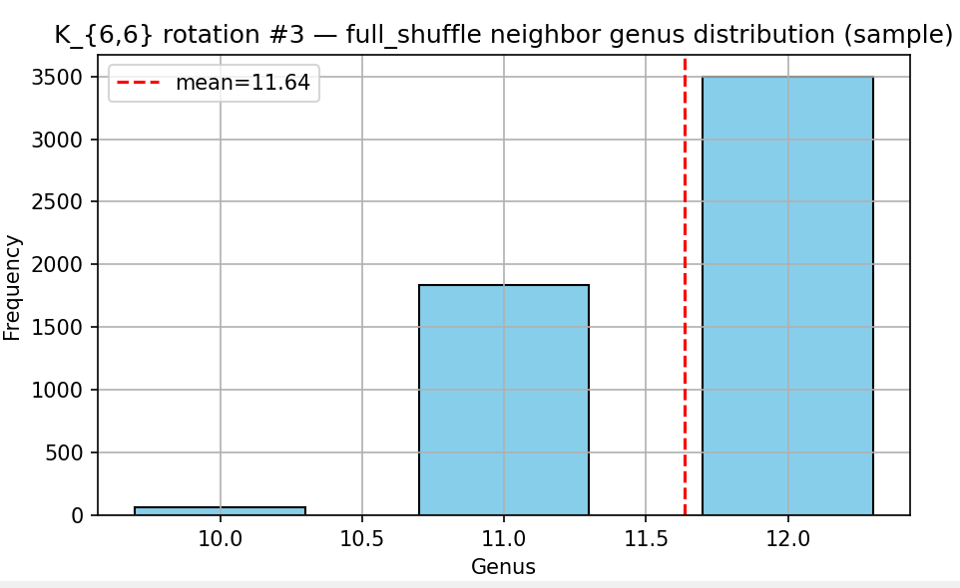
  - 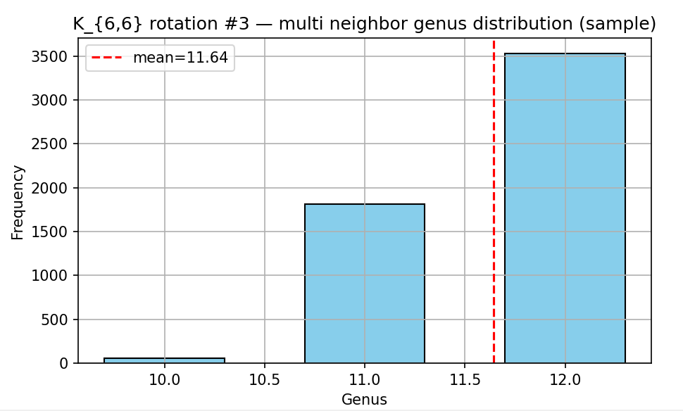

Local Minimum using hill climbing

- K(4,4)
- Run 1
  - 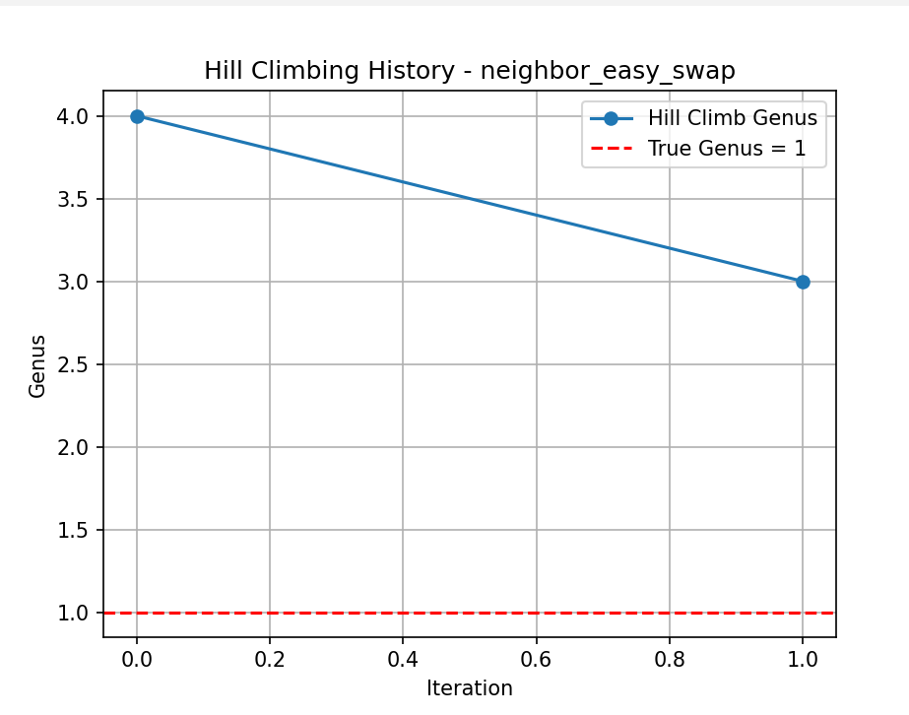
  - 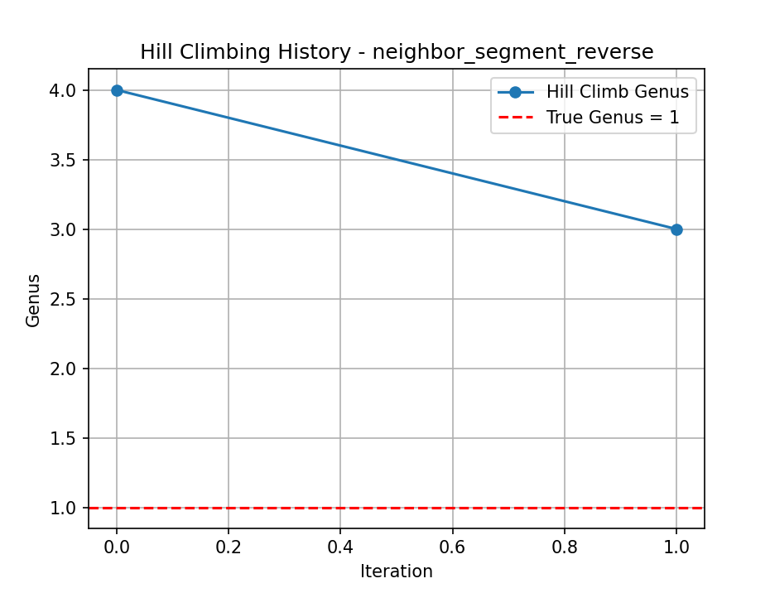
  - 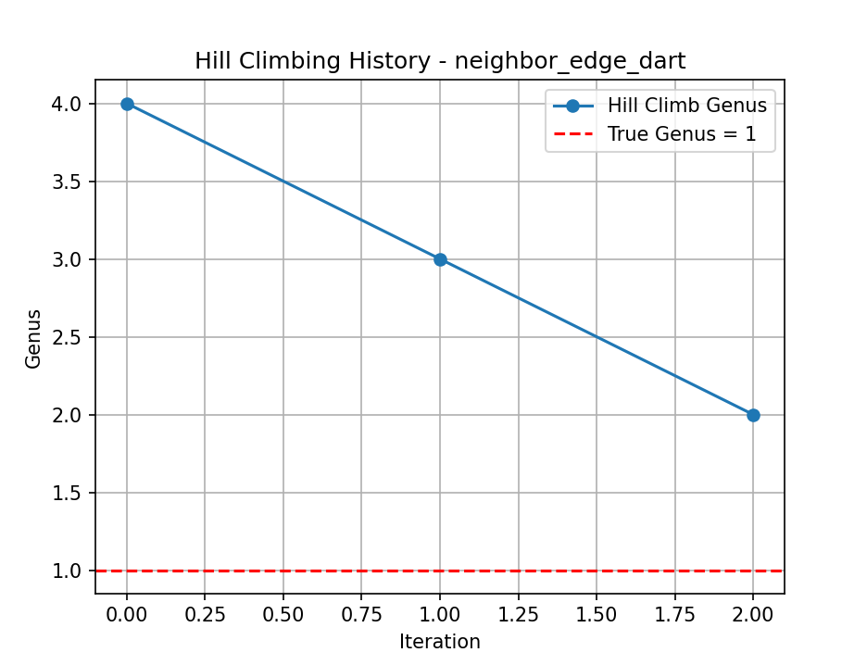
  - 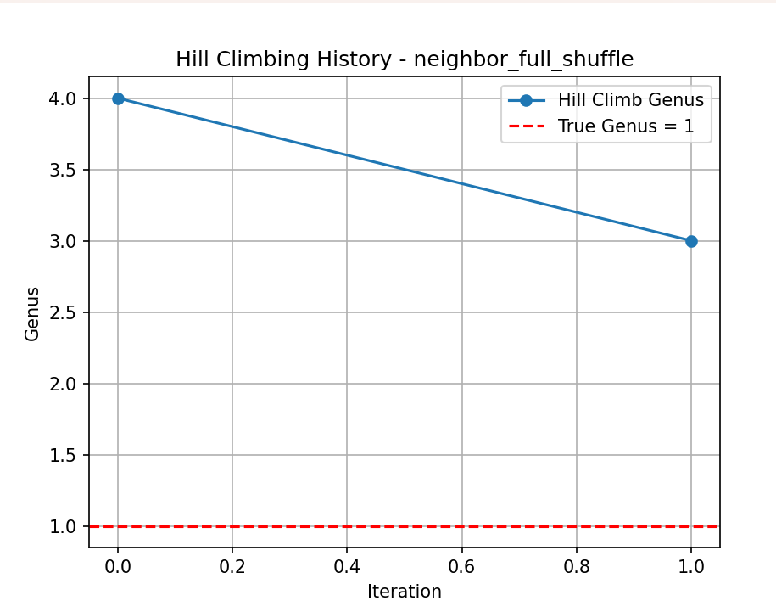
- Run 2
  - 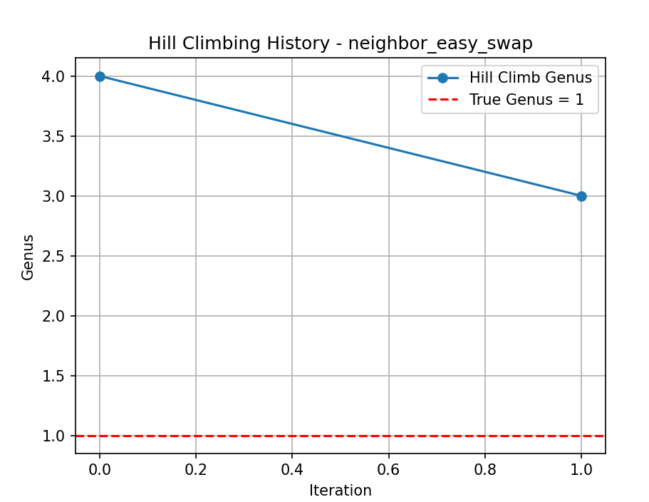
  - 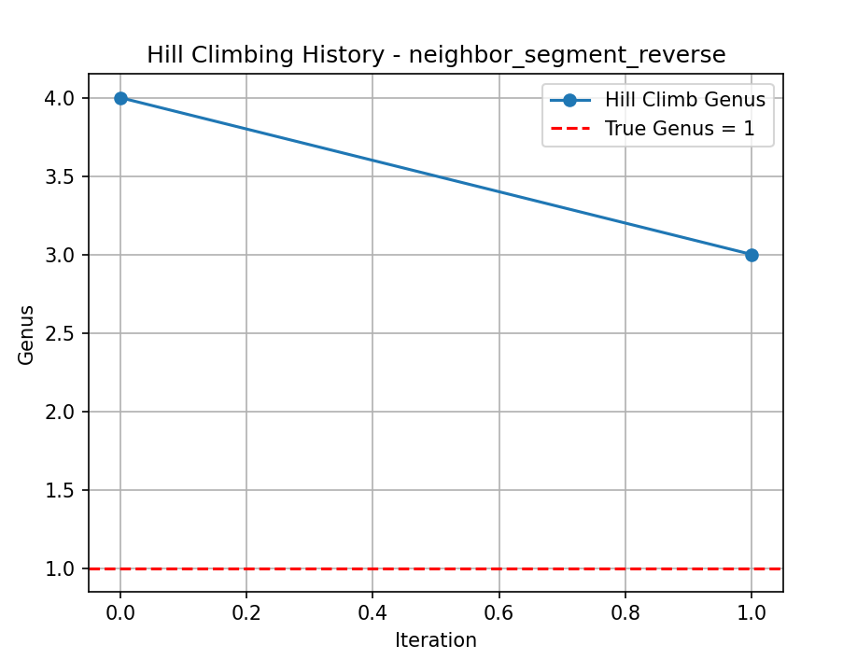
  - 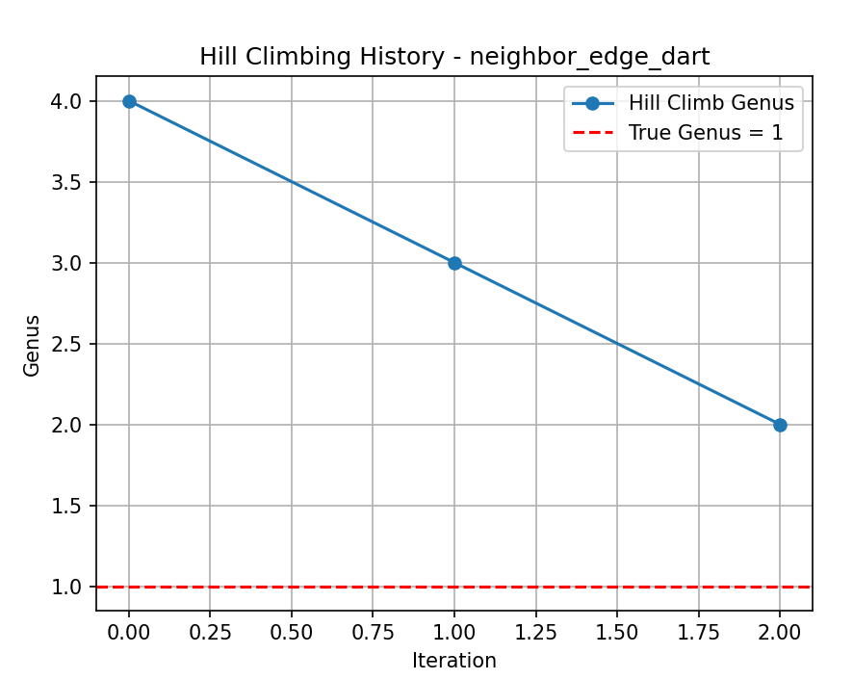
  - 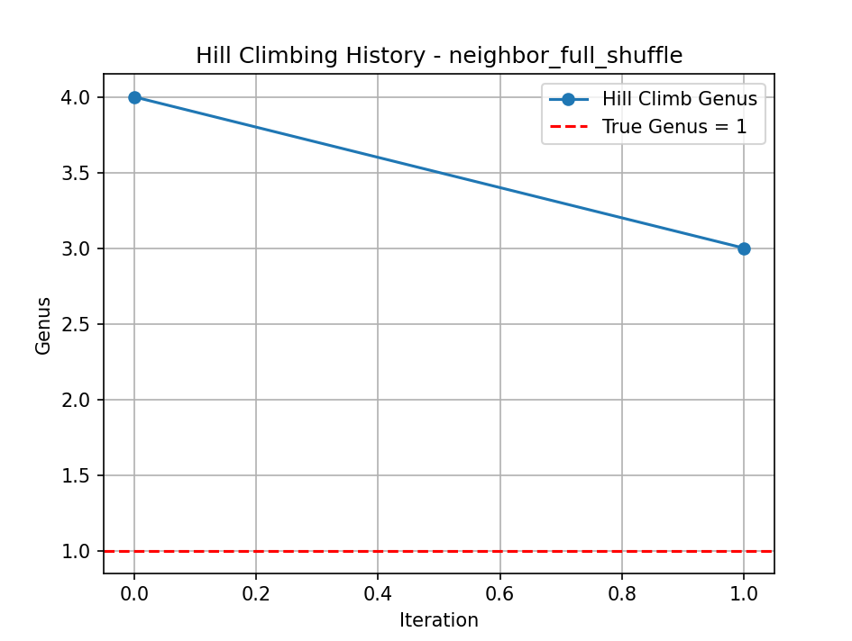

- K(5,5)
- Run 1
  - 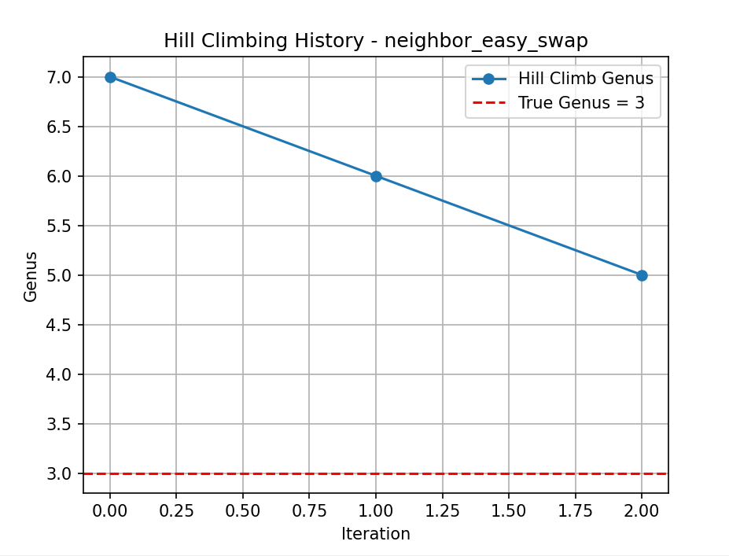
  - 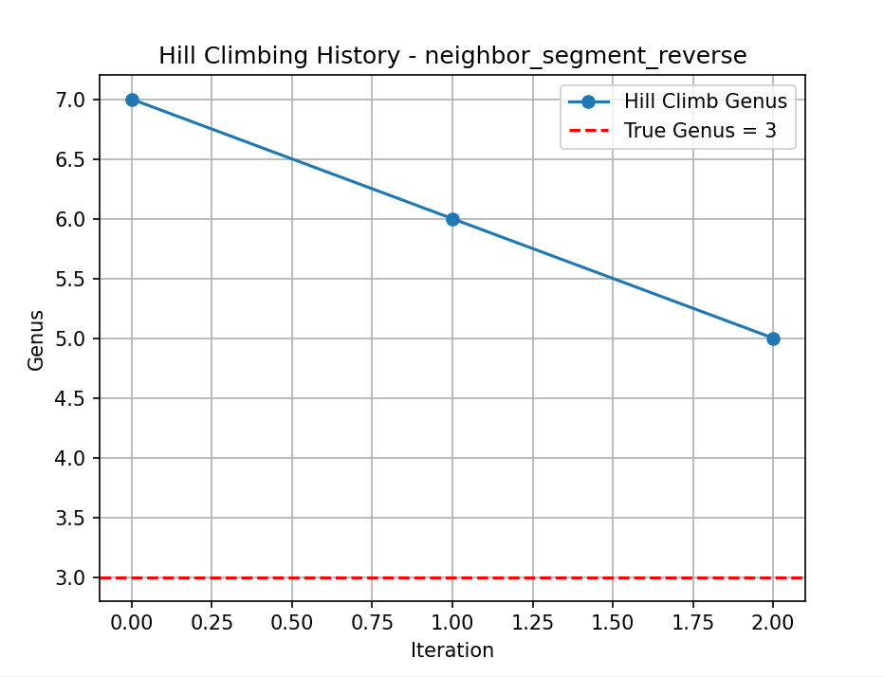
  - 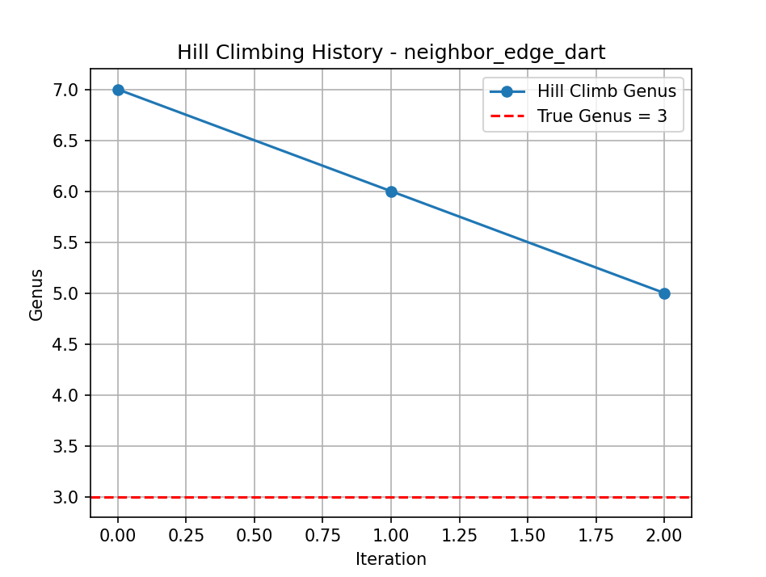
  - 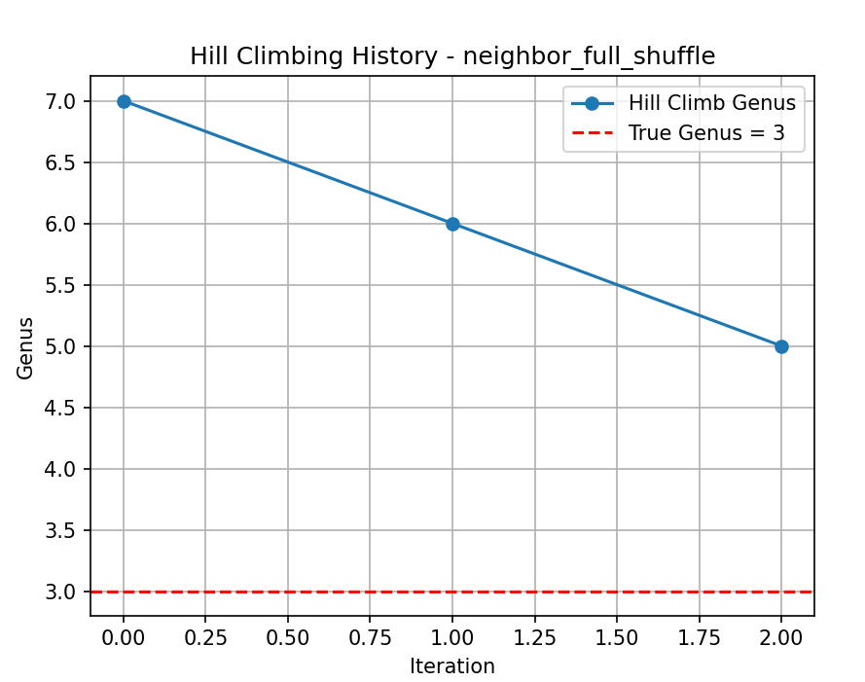
  - ...

ADVANCED
- K(4,4)
  - 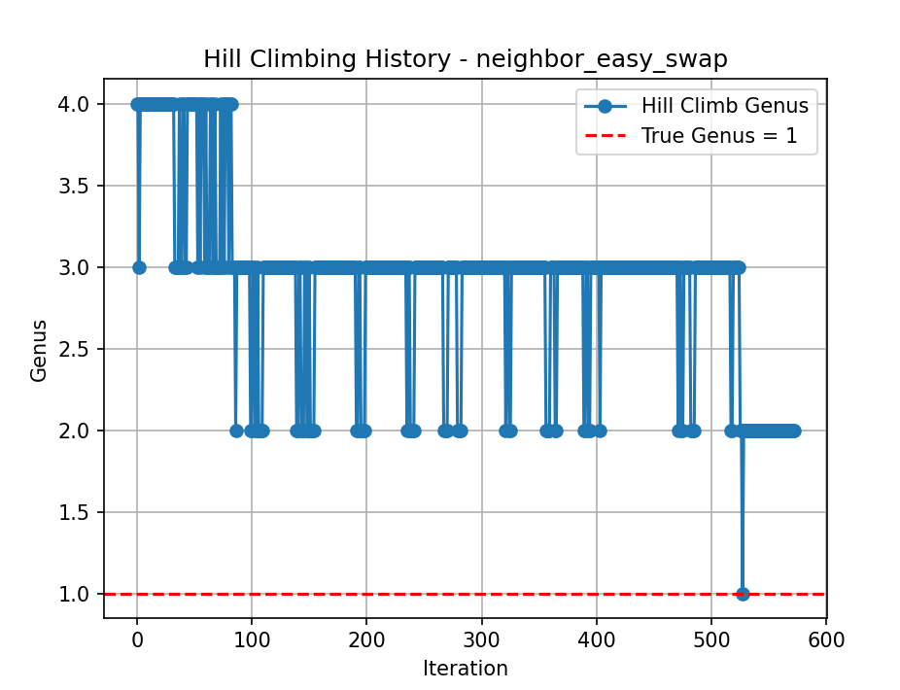
  - 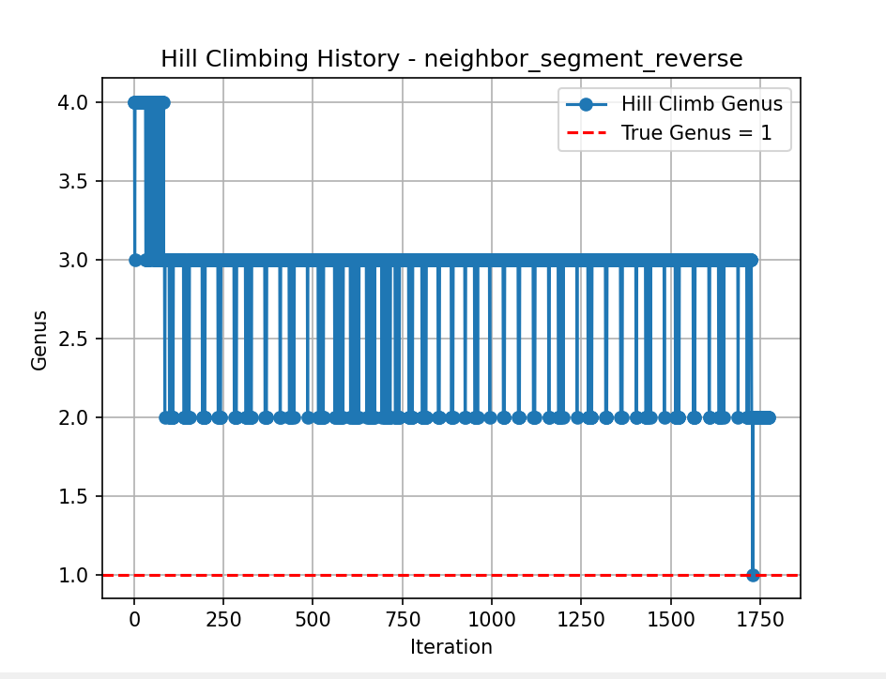
  - 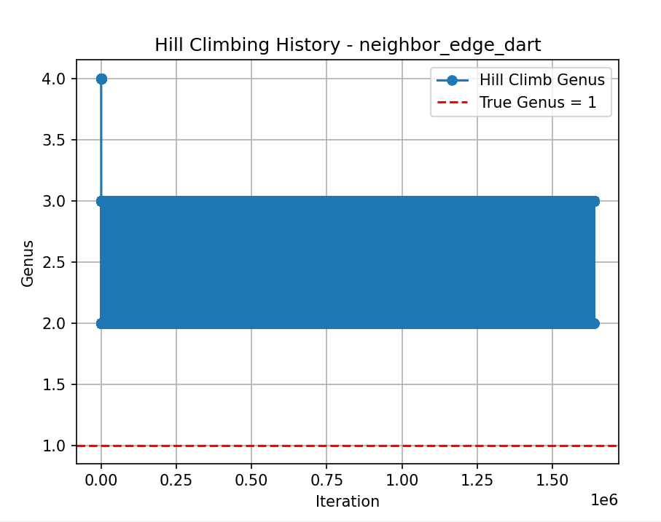
  - 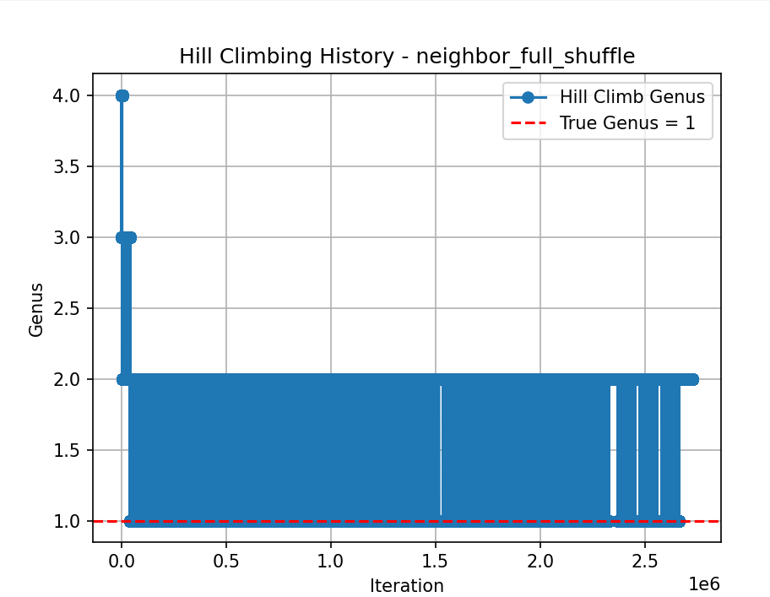

Oct 30
- n=k | Computed genus | Theoretical genus
---------------------------------------------
3 | 1.0 | 1
4 | 3.0 | 1
5 | 6.0 | 3
6 | 10.0 | 4
7 | 15.0 | 7
8 | 21.0 | 9
9 | 28.0 | 13
10 | 36.0 | 16
11 | 45.0 | 21
12 | 55.0 | 25
13 | 66.0 | 31
14 | 78.0 | 36
15 | 91.0 | 43
16 | 105.0 | 49
17 | 120.0 | 57

